Data Analytics Capstone
Analysis of Facility and Unit Attributes under the EPA Clean Air Markets Program Using Statistical and Machine Learning Techniques
Final Report
Dhananjay Verma (Student ID: 0291493)
Walsh College
Division of Mathematics and Computer Science
QM640 V1: Data Analytics Capstone
Mentor Name: Dr. Javad Katibai
Summer 2026 Term
October 15, 2026

GitHub Repository, Data Files, and Standalone Declaration
In accordance with the QM640 Final Report formatting requirements ('After the title page, add your GitHub link with the data files and codes'), all raw datasets, processed analytical files, Python scripts, statistical outputs, and publication-grade figures are permanently archived and publicly accessible in the official project GitHub repository:
GitHub Repository Root: https://github.com/djmsritai-tech/QM640-Data-Analytics-Capstone
Raw Data File URL (facility-2025.csv): https://github.com/djmsritai-tech/QM640-Data-Analytics-Capstone/blob/main/data/raw/facility-2025.csv
Processed/Clean Data URL (facility_clean_processed.csv): https://github.com/djmsritai-tech/QM640-Data-Analytics-Capstone/blob/main/data/processed/facility_clean_processed.csv
Python Analytical & Report Scripts: https://github.com/djmsritai-tech/QM640-Data-Analytics-Capstone/tree/main/scripts
High-Resolution Figures (300 DPI): https://github.com/djmsritai-tech/QM640-Data-Analytics-Capstone/tree/main/outputs/figures
Repository Directory Architecture:
QM640-Data-Analytics-Capstone/
│
├── data/
│ ├── raw/
│ │ └── facility-2025.csv [Raw EPA CAMPD dataset: 4,050 rows, 30 columns]
│ └── processed/
│ └── facility_clean_processed.csv [Engineered dataset: 4,050 rows, 45 columns]
│
├── scripts/
│ ├── run_capstone_analytics.py [End-to-end Python statistical & ML pipeline]
│ ├── build_full_interim_report.py [APA 7 Interim Report generation script]
│ └── build_full_final_report.py [APA 7 Final Report generation script]
│
├── outputs/
│ ├── analytics_results.json [Complete JSON export of test statistics & metrics]
│ └── figures/ [11 publication-grade PNG figures at 300 DPI]
│
└── reports/
├── QM 640_Interim_Report_DhananjayVerma-0291493.docx & .pdf
└── QM 640_Final_Report_DhananjayVerma-0291493.docx & .pdf
Standalone Publication Notice: The Final Report is constructed as an autonomous, standalone publication-grade manuscript. Although it builds upon the research trajectory established during the Capstone Synopsis and Interim Report phases, zero external dependency is assumed. All domain contexts, data dictionaries, mathematical formulations, statistical power proofs, system architecture diagrams, empirical evaluations, deployment blueprints, and code listings (Appendices A–D) are self-contained herein.
Abstract
Stationary fossil-fuel electric power generating facilities regulated under the United States Environmental Protection Agency (EPA) Clean Air Markets Program (CAMP) exhibit massive heterogeneity in thermal combustion intensity, installed electrical capacity, boiler vintage, and pollution abatement hardware. Traditional regulatory compliance auditing frequently relies on coarse fuel-level classifications, failing to capture non-linear multidimensional interactions among boiler design, unit age, regional regulatory regimes, and multi-pollutant scrubber adoption. To address this operational gap, this study develops an integrated, end-to-end statistical, econometric, and machine learning framework analyzing the complete 2025 EPA Clean Air Markets Program Data (CAMPD) bulk dataset comprising N = 4,050 generating units across 1,328 unique power plants in 52 U.S. jurisdictions. Zero records were discarded through domain-informed regex capacity parsing and unit-technology median imputation. Four core analytical methodologies were executed: (1) parametric One-Way Analysis of Variance (ANOVA) and non-parametric Kruskal-Wallis rank testing to evaluate fuel-driven thermal disparities; (2) supervised binary classification utilizing L2-regularized Logistic Regression, Random Forest (150 trees), and Gradient Boosting (100 trees) evaluated on a stratified 80% training set (N = 3,240, 5-fold cross-validation) and 20% holdout test set (N = 810) to predict top-quartile high-emission units (Max Hourly Heat Input Rate >= 2,350.0 mmBtu/hr); (3) bivariate and multivariate Ordinary Least Squares (OLS) regressions quantifying unit vintage and scale effects; and (4) unsupervised K-Means clustering coupled with two-dimensional Principal Component Analysis (PCA) to segment the national fleet. Empirical results prove that primary fuel category explains 34.91% of total thermal variance (F = 542.36, p < 0.0001; H = 783.02, p < 0.0001), with coal units averaging 5,221.2 mmBtu/hr versus 1,553.0 mmBtu/hr for natural gas. In holdout testing, Gradient Boosting achieved 96.54% accuracy, 94.44% precision, F1 = 0.9303, and ROC-AUC = 0.9865, while Random Forest achieved 93.14% sensitivity (identifying 190 of 204 high emitters, ROC-AUC = 0.9851), substantially outperforming baseline linear classification (89.14% accuracy, F1 = 0.8053). Multivariate OLS explained 76.68% of thermal variance (F = 4,435.0, p < 0.0001), and K-Means identified k = 4 cohesive fleet archetypes (Silhouette = 0.4431, PCA variance = 80.19%), isolating 414 aging coal baseload units with an 86.0% high-emitter rate for targeted EPA compliance auditing and utility retirement planning.
Problem: Stationary power generation units exhibit complex, non-linear operational and emission-risk disparities across fuel types, boiler technologies, and unit vintages that simple regulatory heuristics fail to predict or segment accurately.
Solution Approach: An end-to-end four-tier quantitative pipeline combining parametric/non-parametric inferential hypothesis testing (One-Way ANOVA, Kruskal-Wallis, Tukey HSD), supervised ensemble machine learning (Random Forest, Gradient Boosting, Ridge Logistic Regression), multivariate OLS econometrics, and unsupervised K-Means clustering with 2D PCA projection.
Data: U.S. EPA Clean Air Markets Program Data (CAMPD) 2025 Facility/Unit Attributes bulk dataset (facility-2025.csv), encompassing N = 4,050 electric power generating units across 1,328 facilities (30 raw attributes expanded to 45 engineered features; 100% data retention).
Technology: Python 3.11 scientific computing stack (Pandas, NumPy, SciPy, Statsmodels, Scikit-Learn, Matplotlib, Seaborn, Python-Docx) executed on a multi-core CPU workstation.
Major Results: Gradient Boosting achieved 96.54% test accuracy, 94.44% precision, F1 = 0.9303, and ROC-AUC = 0.9865 (+12.50% F1 improvement over linear baseline); Random Forest achieved 93.14% recall and ROC-AUC = 0.9851; Multivariate OLS achieved R² = 0.7668; K-Means (k = 4) captured 80.19% PCA variance.
Implementation Area: Federal and state environmental compliance auditing (U.S. EPA Regions 1–10), continuous emission monitoring system (CEMS) anomaly surveillance, and electric utility integrated resource planning (IRP) for coal-to-gas asset retirement.

1. Introduction
Background and Context
Atmospheric pollution originating from stationary fossil-fuel combustion sources remains one of the most consequential environmental, public health, and regulatory challenges in the United States. Electric utility and industrial power generating facilities combusting bituminous coal, sub-bituminous coal, lignite, pipeline natural gas, and distillate or residual fuel oils represent the nation's largest point sources of criteria air pollutants and hazardous air toxics. Specifically, high-temperature boiler and turbine combustion processes release sulfur dioxide (SO₂), nitrogen oxides (NOₓ), filterable and condensable particulate matter (PM₂.₅ and PM₁₀), elemental and oxidized mercury (Hg), and greenhouse gases (CO₂). Extensive epidemiological and environmental economics research has established that ambient exposure to fine sulfate and nitrate aerosols—formed via atmospheric oxidation of SO₂ and NOₓ—induces severe cardiopulmonary morbidity, premature mortality, acid deposition in aquatic ecosystems, and regional visibility impairment (Harrington et al., 2004; Burtraw et al., 2012).
To mitigate these environmental externalities cost-effectively, the U.S. Congress and the United States Environmental Protection Agency (EPA) instituted landmark market-based cap-and-trade and command-and-control frameworks under Title IV and Title I of the Clean Air Act Amendments of 1990. These statutory programs include the Acid Rain Program (ARP), the Cross-State Air Pollution Rule (CSAPR, encompassing the CSNOX, CSNOXOS, and CSSO2G1/G2 trading groups), the Mercury and Air Toxics Standards (MATS), and the Regional Greenhouse Gas Initiative (RGGI). The operational backbone of these regulatory instruments is the EPA Clean Air Markets Program (CAMP), which mandates that regulated power plants install, calibrate, and operate automated Continuous Emission Monitoring Systems (CEMS) in strict compliance with 40 CFR Part 75 (U.S. EPA, 2024). Through CAMPD, the federal government maintains an authoritative, unit-level registry documenting physical boiler design, nameplate electrical capacity, maximum hourly thermal heat input rate, commercial operation date, primary and secondary fuel types, and installed pollution abatement technologies.
The operational setting of this research is the contemporary United States bulk electric power system during the calendar year 2025. Over the past two decades, the U.S. generating fleet has undergone a profound structural transformation driven by declining natural gas prices, renewable portfolio standards, and stringent environmental compliance costs (Schmalensee & Stavins, 2017; Ellis et al., 2019). This transition has produced a highly bifurcated fleet architecture: aging, large-scale subcritical and supercritical coal-fired steam boilers commissioned prior to 1985 operate alongside a rapidly expanding cohort of modern natural gas combined cycle (NGCC) plants and fast-ramping simple-cycle combustion turbines designed to balance intermittent wind and solar generation. Concurrently, legacy steam units that remain active have been heavily retrofitted with multi-stage post-combustion abatement hardware—such as wet limestone flue gas desulfurization (FGD) scrubbers, selective catalytic reduction (SCR) systems, electrostatic precipitators (ESP), fabric filter baghouses, and activated carbon injection (ACI)—creating intricate dependencies between unit age, physical scale, and environmental compliance.
Within this regulatory and operational landscape, key stakeholders include federal EPA enforcement directors across Regions 1 through 10, state departments of environmental quality, Independent System Operators (ISOs) and Regional Transmission Organizations (RTOs), electric utility fleet engineers, and environmental, social, and governance (ESG) institutional analysts. For these stakeholders, accurately quantifying the drivers of thermal combustion capacity, predicting which generating units pose acute high-emission risks, and classifying the heterogeneous 4,050-unit fleet into actionable operational archetypes are vital prerequisites for allocating finite field inspection budgets, ensuring grid reliability during peak seasonal demand, and structuring orderly asset retirement schedules.
Problem Statement (Single, Measurable; Include Y and X)
Formal Measurable Problem Statement: The objective of this study is to explain, predict, and segment Y = maximum hourly thermal heat input capacity (Max Hourly HI Rate, measured continuously in mmBtu/hr) and binary top-quartile high-emission compliance status (High_Emitter ∈ {0, 1}, defined as Heat Input Rate >= 2,350.0 mmBtu/hr) for electric power generating units (N = 4,050 units across 1,328 U.S. facilities) using X = primary fuel category, unit combustion technology, installed electrical nameplate capacity (Capacity_MW), operating vintage (Unit_Age), multi-pollutant abatement hardware density (Control_Count), and EPA regional jurisdiction over the 2025 reporting period. Success will be evaluated using One-Way ANOVA F-statistics, Eta-squared (η²) effect size, and Kruskal-Wallis H-statistics for fuel variance; holdout test Accuracy, Precision, Recall, F1-Score, and Receiver Operating Characteristic Area Under the Curve (ROC-AUC) for classification; Coefficient of Determination (R²), Adjusted R², and Root Mean Squared Error (RMSE) for econometric regression; and Within-Cluster Sum of Squares (WCSS), Silhouette Coefficient, and Cumulative Explained Variance (%) for unsupervised segmentation.
Despite the availability of rich unit-level attribute registries under CAMPD, conventional regulatory oversight often relies on static, univariate rules of thumb—such as auditing facilities solely by fuel type or raw megawatt rating—without accounting for the confounding effects of thermodynamic cycle efficiency, unit grandfathering, and scrubber retrofits. When regulatory agencies lack validated predictive classifiers and multidimensional fleet taxonomies, compliance surveillance becomes either overly broad (wasting inspection resources on low-risk peaking turbines) or overly narrow (failing to detect high-intensity intermediate boilers). Resolving this analytical gap requires a unified framework that bridges classical parametric/non-parametric inference with modern ensemble machine learning and unsupervised pattern recognition.
Purpose of the Study
The purpose of this capstone study is to design, execute, and validate a comprehensive multi-tier data analytics pipeline on the complete 2025 U.S. EPA Clean Air Markets Program facility dataset (N = 4,050 units). Specifically, the study aims to: (1) statistically explain and quantify the variance in thermal combustion capacity across primary fuel categories using both parametric and rank-based non-parametric tests; (2) train, cross-validate, and benchmark supervised machine learning classifiers (Logistic Regression, Random Forest, and Gradient Boosting) to predict high-emission generating units and rank the underlying physical and regulatory drivers; (3) estimate bivariate and multivariate econometric regression models isolating the net effect of unit vintage (age) from installed capacity and pollution control retrofits; and (4) segment the national power fleet into cohesive, mathematically validated operational archetypes via K-Means clustering and Principal Component Analysis (PCA) to guide real-world regulatory enforcement and utility resource planning.
Research Problems / Research Questions
To fulfill the study's purpose and operationalize the problem statement, four specific research questions (RQ1–RQ4) are formally investigated across the 4,050 regulated generating units:
Research Question 1 (RQ1 — Inferential Variance Analysis): Do facility and unit attributes—specifically primary fuel category (Coal, Natural Gas, Oil/Diesel, Biomass, Other) and boiler/turbine technology—significantly influence maximum hourly heat input rates (mmBtu/hr) across the U.S. electric power fleet, and what proportion of total thermal variance is attributable to fuel selection?
Research Question 2 (RQ2 — Supervised Risk Classification): Can supervised machine learning algorithms trained on unit-level physical and regulatory attributes (installed electrical capacity, operating vintage, pollution control count, fuel category, unit technology, and EPA region) accurately classify and predict high-emission generating units (upper quartile, Max Hourly HI Rate >= 2,350.0 mmBtu/hr), and which features contribute most to predictive discrimination?
Research Question 3 (RQ3 — Econometric Vintage & Scale Modeling): What is the direction, magnitude, and statistical significance of the relationship between generating unit age (years since commercial operation) and operational thermal intensity in both bivariate analyses and multivariate regressions controlling for nameplate capacity and pollution abatement equipment?
Research Question 4 (RQ4 — Unsupervised Fleet Segmentation): Can the heterogeneous national generating fleet of 4,050 units be partitioned via unsupervised clustering and dimensionality reduction into distinct, internally cohesive operational and environmental-risk archetypes that support tiered regulatory auditing?
Contributions and Expected Value
Practical Contribution: This study delivers an immediately deployable, data-driven compliance screening tool that enables environmental regulators and utility managers to transition from manual spreadsheet filtering to automated probabilistic risk scoring. By isolating the exact physical thresholds and technology combinations associated with top-quartile thermal loading, the framework streamlines environmental audit scheduling and identifies aging, uncontrolled steam units primed for economic retirement.
Technical Contribution (Methods/Models): From a methodological perspective, this capstone demonstrates the analytical synergy of integrating four distinct paradigms—parametric/rank ANOVA with Tukey HSD post-hoc contrasts, L2-regularized and tree-ensemble classifiers (Random Forest and Gradient Boosting) with stratified k-fold cross-validation, Gauss-Markov OLS econometric regressions uncovering confounding variable reversals (Simpson's/omitted-variable dynamics), and log-standardized K-Means clustering paired with orthogonal PCA projection—within a reproducible, zero-data-loss Python software architecture.
Value to Stakeholders and Target Users: For EPA regional enforcement officers, the models provide high-sensitivity (93.14% recall) and high-precision (94.44% precision) screening of high-emission units, minimizing false-negative regulatory oversights and false-positive inspection costs. For electric utility planners and ISO grid operators, the four empirical fleet clusters establish objective peer benchmarks for evaluating heat rate efficiency, scrubber capital intensity, and baseload-to-peaking transition risk.
2. Literature Review
Literature Review Approach
A rigorous, systematic literature review was conducted to ground the study's research questions, variable selection, statistical formulations, and machine learning architectures in established peer-reviewed scholarship. Academic databases queried included IEEE Xplore, ScienceDirect, Elsevier Energy Policy, JSTOR, SpringerLink, the American Statistical Association (ASA) digital archive, and Google Scholar, alongside statutory technical documentation from the U.S. Environmental Protection Agency. Search strings combined domain and methodological keywords using Boolean operators: ('Clean Air Markets Program' OR 'Acid Rain Program' OR 'CAMPD' OR '40 CFR Part 75') AND ('heat input rate' OR 'boiler vintage' OR 'flue gas desulfurization' OR 'unit attributes') AND ('ANOVA' OR 'Kruskal-Wallis' OR 'Random Forest' OR 'Gradient Boosting' OR 'K-Means clustering' OR 'principal component analysis').
Literature inclusion criteria mandated that selected works be either: (a) empirical studies published in peer-reviewed energy economics or environmental policy journals examining stationary power plant emissions and compliance behavior; (b) foundational mathematical statistics and machine learning treatises establishing the asymptotic properties, effect size metrics, and validation protocols of the algorithms deployed; or (c) authoritative federal data standards governing electric utility telemetry. Studies focusing exclusively on mobile vehicular tailpipe emissions or theoretical macro-climate models without facility-level granularity were excluded. Fourteen foundational sources satisfying these criteria were synthesized and mapped directly to RQ1–RQ4.
Summary of Key Literature (14 Foundational Sources)
Table 1 presents the comprehensive Literature Relevance Matrix, detailing for each of the 14 sources the author(s) and publication year, domain and context, dataset or analytical setting, statistical and machine learning methods, primary empirical or theoretical findings, and explicit support for our research questions and modeling decisions.
Table 1
Literature Relevance Matrix
Author (Year) | Domain/Context | Dataset/Setting | Method(s) | Key Findings | How it supports RQ(s) / project decisions
U.S. EPA (2024) | Federal Environmental Regulation | CAMPD Bulk Data Files (4,050 U.S. units, 2025) | Continuous Emission Monitoring (40 CFR Part 75) | Establishes standardized unit-level reporting for heat input, capacity, fuel, and abatement controls. | Primary data source and schema foundation for all variables across RQ1–RQ4.
Ellis et al. (2019) | Energy Policy & Emissions Trading | U.S. Fossil-Fuel Power Fleet (CAMPD) | Econometric Panel & Policy Evaluation | Market-based trading induced rapid coal-to-gas switching and concentrated emissions in legacy baseload units. | Motivates RQ1 fuel comparisons and RQ2 high-emitter predictive features.
Schmalensee & Stavins (2017) | Environmental Economics | 30-Year Cap-and-Trade Retrospective | Economic Cost-Benefit & Institutional Analysis | Allowance trading reduced SO2 and NOx compliance costs by 40–60% vs command-and-control mandates. | Justifies encoding regulatory program participation and control counts in RQ2 & RQ3.
Burtraw et al. (2012) | Electricity Grid & Carbon Policy | National Electric Reliability Council Regions | Capacity Expansion & Dispatch Simulation | Unit vintage, thermal heat rate, and scrubber retrofits govern plant retirement vs continued baseload operation. | Directly supports RQ3 age-intensity regression and RQ4 fleet archetype clustering.
Harrington et al. (2004) | Regulatory Instrument Design | U.S. and European Industrial Point Sources | Comparative Empirical Policy Audit | Continuous monitoring paired with targeted enforcement audits maximizes environmental compliance. | Provides practical policy justification for RQ2 automated audit screening.
Hollander et al. (2014) | Nonparametric Statistical Methods | Skewed Industrial & Biometric Distributions | Kruskal-Wallis Rank-Sum & Distribution-Free Tests | Rank-based omnibus tests preserve Type I error control and asymptotic power under heavy right-skewness. | Methodological basis for coupling Kruskal-Wallis with ANOVA in RQ1.
Gibbons & Chakraborti (2011) | Mathematical Statistics | Asymptotic Relative Efficiency Proofs | Rank Order Statistics & Multiple Comparisons | Non-parametric rank tests achieve >95% efficiency vs parametric F-tests even under Gaussian conditions. | Validates robustness of RQ1 rank testing and RQ3 Spearman rank correlation.
Montgomery et al. (2021) | Applied Regression Econometrics | Engineering & Industrial Process Data | OLS Estimation, Variance Inflation, Diagnostics | Demonstrates how omitted scale variables bias bivariate slopes and how multivariate OLS isolates partial effects. | Directly explains the bivariate-to-multivariate age slope reversal in RQ3.
Field (2018) | Quantitative Research Methodology | Behavioral & Physical Science Datasets | One-Way ANOVA, Eta-Squared (η²), Tukey HSD | Establishes effect size thresholds (η² > 0.14 = large effect) and family-wise error control via Tukey HSD. | Supplies exact mathematical formulations for RQ1 omnibus and post-hoc tests.
Cochran (1977) | Sampling Theory & Power Analysis | Finite & Infinite Population Surveys | Stratified Allocation & Sample Size Bounds | Derives minimum sample size equations for group means, proportions, and stratified holdout estimation. | Validates that N = 4,050 (3,240 train / 810 test) exceeds minimum bounds by 5x–22x.
Kruskal & Wallis (1952) | Seminal Statistical Theory | Multi-Group Independent Samples | H-Statistic Chi-Square Approximation | Formulates the exact rank-sum test statistic H for testing stochastic equality across k groups. | Foundational mathematical equation implemented for RQ1 fuel variance testing.
Breiman (2001) | Ensemble Machine Learning | High-Dimensional Classification Benchmarks | Random Forests, Bagging, Gini Impurity MDI | Bootstrap aggregation of randomized trees reduces variance without increasing bias and yields robust feature importance. | Core algorithm for RQ2 classification (93.14% recall) and feature ranking.
Friedman (2001) | Statistical Learning & Boosting | Additive Expansion in Function Space | Gradient Boosting Machines (GBM) | Stage-wise additive trees fitted to negative loss gradients achieve state-of-the-art tabular classification accuracy. | Primary champion classifier in RQ2 (96.54% accuracy, ROC-AUC = 0.9865).
MacQueen (1967) | Unsupervised Pattern Recognition | Multivariate Euclidean Spaces | K-Means Centroid Partitioning | Iterative minimization of within-cluster sum of squares (WCSS) partitions N observations into k Voronoi cells. | Algorithmic foundation for RQ4 fleet segmentation into k = 4 operational archetypes.
Note. Synthesis of 14 peer-reviewed and statutory sources establishing theoretical and methodological foundations for RQ1–RQ4.
Thematic Synthesis of Literature
Theme 1: Market-Based Environmental Regulation and Fuel-Driven Emission Disparity (Supporting RQ1). A substantial body of environmental economics literature (Schmalensee & Stavins, 2017; Ellis et al., 2019; Harrington et al., 2004) documents how statutory cap-and-trade programs—beginning with Title IV of the 1990 Clean Air Act Amendments and evolving through CSAPR and MATS—reshaped the technological composition of the U.S. electric power sector. By pricing SO₂ and NOₓ emission allowances and mandating strict mercury limits, these policies accelerated the retirement of smaller, inefficient coal boilers while concentrating solid-fuel generation within massive baseload steam units capable of amortizing hundred-million-dollar scrubber retrofits. Simultaneously, deregulated wholesale electricity markets favored the rapid buildout of modular natural gas combustion turbines and combined cycle plants (U.S. EPA, 2024). Consequently, primary fuel type is no longer merely a chemical input; it proxies distinct thermodynamic architectures and physical combustion scales. This literature directly motivates RQ1, which tests whether primary fuel categories exhibit statistically significant divergence in maximum hourly heat input.
Theme 2: Generating Unit Vintage, Regulatory Grandfathering, and Scale Confounding (Supporting RQ3). Power systems engineering and econometric studies (Burtraw et al., 2012; Montgomery et al., 2021) highlight a critical structural phenomenon in the U.S. fleet known as regulatory 'grandfathering.' Under New Source Performance Standards (NSPS), stringent abatement mandates applied primarily to newly constructed facilities, creating strong economic incentives for utilities to extend the operational lifespan of large coal-fired steam boilers built in the 1960s and 1970s. Conversely, capacity additions since 2000 have been dominated by modular gas turbines with smaller per-unit megawatt footprints. In cross-sectional data, this historical evolution induces positive confounding between unit age and thermal input capacity: older units appear more thermally intensive in bivariate correlations primarily because legacy surviving units are large baseload boilers, whereas conditional on nameplate electrical capacity, modern combined cycle configurations achieve higher thermal packing density. Montgomery et al. (2021) emphasize that resolving such confounding requires comparing simple bivariate OLS against multivariate OLS models controlling for physical scale and abatement hardware—precisely the econometric design executed in RQ3.
Theme 3: Parametric and Non-Parametric Dual Inference on Skewed Industrial Data (Supporting RQ1 & RQ3). Methodological treatises in mathematical statistics (Kruskal & Wallis, 1952; Gibbons & Chakraborti, 2011; Hollander et al., 2014; Field, 2018) demonstrate that industrial facility datasets routinely violate Gaussian normality and homoscedasticity assumptions due to extreme right-skewness (e.g., thousands of 50 MW peaking turbines coexisting with 1,300 MW supercritical boilers). While One-Way ANOVA is asymptotically robust under large sample sizes (Cochran, 1977), heavy tails can inflate variance estimates and distort p-values in unbalanced groups. Therefore, best-practice statistical rigor dictates pairing parametric One-Way ANOVA (reporting F-statistics, Eta-squared η² effect sizes, and Tukey HSD family-wise error-controlled contrasts) with the distribution-free Kruskal-Wallis H-test, and pairing Pearson linear correlation (r) with Spearman rank-order correlation (ρ).
Theme 4: Ensemble Machine Learning for Compliance Risk Classification (Supporting RQ2). In predictive analytics for tabular regulatory data, Breiman (2001) and Friedman (2001) proved that tree-based ensemble architectures—Random Forests and Gradient Boosting Machines—consistently outperform generalized linear models by automatically capturing non-linear threshold effects and high-order interactions (such as the interaction between coal combustion, boiler design, and multi-pollutant scrubber counts). While regularized Logistic Regression serves as an essential probabilistic linear benchmark, ensemble trees evaluated via stratified k-fold cross-validation and Receiver Operating Characteristic Area Under the Curve (ROC-AUC) maximize sensitivity and precision under moderate class imbalance (25.14% high-emitter prevalence).
Theme 5: Unsupervised Fleet Taxonomy and Modern AI Extensions (Supporting RQ4 & Future Scope). Finally, MacQueen (1967) established K-Means clustering as a mathematically tractable method for partitioning multidimensional observations into homogeneous operational regimes. When applied to log-transformed, Z-score standardized facility attributes and projected onto orthogonal axes via Principal Component Analysis (PCA), unsupervised clustering uncovers latent fleet archetypes without reliance on pre-assigned labels. Furthermore, recent advances in deep learning for temporal CEMS telemetry and agentic large language model (LLM) compliance assistants build directly upon structured tabular baselines, positioning the present analytical pipeline as a foundational layer for next-generation automated environmental governance.
3. Materials and Method
Data Sources, Access, and Inclusion/Exclusion Criteria
The empirical dataset analyzed in this study was acquired from the official United States Environmental Protection Agency (EPA) Clean Air Markets Program Data (CAMPD) bulk data repository (https://campd.epa.gov/data/bulk-data-files), specifically the 2025 Facility and Unit Attributes registry (facility-2025.csv). Under federal statute (40 CFR Part 75), all regulated electric generating units (EGUs)—typically fossil-fuel-fired boilers and turbines with nameplate capacities exceeding 25 MWe that supply electricity for sale to the grid—are legally mandated to submit verified unit-level technical and compliance attributes to the EPA. No web scraping of unstructured HTML was required, as the EPA provides authoritative comma-separated values (CSV) bulk exports.
The raw dataset comprises exactly N = 4,050 generating unit records distributed across 1,328 unique power generation facilities spanning 52 U.S. jurisdictions (all 50 states, the District of Columbia, and Puerto Rico) with 30 raw attribute columns. Explicit inclusion and exclusion criteria were established prior to preprocessing: (1) all regulated stationary power generating units registered in the 2025 CAMPD bulk file were included to preserve complete national population coverage; (2) primary key uniqueness was audited on the composite key (Facility ID + Unit ID), confirming zero duplicate records; and (3) rather than performing listwise deletion on records with partial missingness in secondary fields—which would introduce selection bias by disproportionately dropping smaller peaking units—domain-informed imputation was applied, achieving 100% data retention (N = 4,050 analyzed records, 0 records excluded). Table 2 presents the comprehensive Data Dictionary for the core raw and engineered attributes (see also Appendix A for the automated parsing code).
Table 2
Data Dictionary for Clean Air Markets Program Facility Attributes
Variable Name | Definition | Datatype | Allowed Values/Range | Missing Handling | Analytical Notes
State | U.S. state or territory postal code of facility | String (Categorical) | 52 jurisdictions | None (0 missing) | Identifies state-level environmental jurisdiction.
Facility ID | Unique federal plant identifier (ORISPL code) | Integer | 3 to 67540 | None (0 missing) | Primary key for facility-level aggregation (1,328 plants).
Facility Name | Official registered power plant name | String | 1,325 unique names | None (0 missing) | Commercial plant designation.
Unit ID | Internal boiler or turbine unit identifier | String | 1,412 unique unit tags | None (0 missing) | Composite primary key with Facility ID (4,050 units).
EPA Region | Federal EPA administrative region (1–10) | Integer (Categorical) | Regions 1 to 10 | None (0 missing) | One-hot encoded to control for regional enforcement.
Unit Type | Combustion boiler or turbine technology | String (Categorical) | 33 raw codes | None (0 missing) | Consolidated into 5 primary technology categories.
Primary Fuel Type | Primary combustible fuel source | String (Categorical) | 12 raw fuel codes | 44 missing (Recoded to Other/Unknown) | Consolidated into 5 fuel categories for RQ1 & RQ2.
Associated Generators & Capacity | Generator ID and nameplate MWe string | String (Formatted text) | e.g., 'GEN1 (153.1)' | 150 missing (3.70% imputed via median) | Parsed via regex to extract continuous Capacity_MW.
Max Hourly HI Rate (mmBtu/hr) | Maximum design hourly thermal heat input rate | Float (Continuous) | 94.0 to 16,250.0 mmBtu/hr | 44 missing (1.09% imputed via ratio) | Continuous dependent variable Y for RQ1 and RQ3.
Commercial Operation Date | Date unit began commercial power generation | Date / String | 1930-01-01 to 2025-11-23 | 36 missing (0.89% imputed via median) | Converted to continuous Unit_Age = 2025 - Year.
Operating Status | Operational status during 2025 reporting year | String (Categorical) | Operating, Retired, Future | None (0 missing) | Recoded into binary Is_Operating indicator.
SO2 / NOx / PM / Hg Controls | Installed pollution abatement hardware strings | String (Multi-valued) | Wet FGD, SCR, ESP, Baghouse, ACI | 596 to 3,877 blank (= Uncontrolled) | Encoded into 4 binary flags and summed into Control_Count.
Capacity_MW | Engineered total unit electrical capacity | Float (Continuous) | 1.0 to 1,300.0 MWe (Mean = 207.2) | 0 missing post-imputation | Primary physical scale predictor in RQ2, RQ3, RQ4.
Unit_Age | Engineered operating vintage in years | Float (Continuous) | 0.0 to 95.0 yrs (Mean = 30.7) | 0 missing post-imputation | Primary explanatory variable in RQ3; predictor in RQ2, RQ4.
Control_Count | Total installed pollution control systems | Integer (Discrete) | 0 to 4 systems (Mean = 1.11) | 0 missing post-engineering | Measures multi-pollutant abatement capital intensity.
High_Emitter | Binary top-quartile thermal emission indicator | Integer (Binary: 0, 1) | 1 if HI >= 2,350 mmBtu/hr (25.14%) | 0 missing post-engineering | Supervised classification target Y for RQ2.
Note. Complete data dictionary of raw EPA CAMPD attributes and engineered analytical features across N = 4,050 units.
Data Cleaning and Preprocessing Log
To transform raw administrative filings into an analysis-ready numerical matrix, an automated eight-stage preprocessing pipeline was implemented in Python (detailed in Appendix A). Table 3 documents each data quality issue identified, the variables affected, the programmatic detection method, the mathematical treatment applied, and the domain rationale.
Table 3
Data Cleaning and Preprocessing Log
Issue Identified | Variables Affected | Detection Method | Treatment Applied | Domain & Statistical Rationale
Duplicate Key Audit | Facility ID + Unit ID | Pandas duplicated() composite check | Verified 0 duplicate unit keys across all 4,050 rows | Guarantees independent observations and prevents variance deflation.
Unstandardized Capacity Text | Associated Generators & Nameplate Capacity (MWe) | Regex pattern r'\(([\d\.]+)\)' | Extracted numeric MWe per generator and summed multi-generator strings | Converts alphanumeric regulatory text into continuous Capacity_MW.
Missing Nameplate Capacity | Capacity_MW | isna().sum() detected 150 missing rows (3.70%) | Imputed using median Capacity_MW grouped by Unit_Type_Category | Preserves all 4,050 records while respecting technology scale differences.
Date String Parsing | Commercial Operation Date | pd.to_datetime(errors='coerce') audit | Extracted year; imputed 36 missing (0.89%) via unit-type median year | Enables exact computation of continuous operating vintage (Unit_Age).
Missing Heat Input Rate | Max Hourly HI Rate (mmBtu/hr) | isna().sum() detected 44 missing rows (1.09%) | Imputed via Capacity_MW × median thermal heat rate ratio (9.5 mmBtu/MWe) | Maintains physical thermodynamic consistency between MWe and heat input.
Implicit Null Controls | SO2, NOx, PM, Hg Controls | Null/blank string audit (596 to 3,877 blanks) | Encoded non-null as 1 (Controlled) and blank as 0 (Uncontrolled) | In CAMPD reporting, blank control fields signify no abatement hardware installed.
Sparse Fuel Categories | Primary Fuel Type (12 raw codes) | Frequency distribution value_counts() check | Consolidated into 5 groups: Natural Gas, Coal, Oil/Diesel, Biomass, Other | Ensures adequate cell counts for ANOVA and prevents dummy-variable sparsity.
Sparse Boiler Technologies | Unit Type (33 raw codes) | Frequency distribution value_counts() check | Consolidated into 5 classes: Combustion Turbine, Combined Cycle, Wall-Fired, Tangential, Other | Prevents high-dimensional overfitting and collinearity in supervised ML models.
Note. Audit log of data cleaning, regular expression parsing, and zero-loss median imputation treatments applied to facility-2025.csv.
Exploratory Data Analysis (EDA)
Comprehensive Exploratory Data Analysis (EDA) was conducted prior to formal modeling to characterize variable distributions, detect skewness and outliers, and verify bivariate relationships across the 4,050 generating units. Across the national fleet, maximum hourly heat input rate averages 1,869.6 mmBtu/hr (SD = 1,973.6 mmBtu/hr), with a median of 1,200.0 mmBtu/hr, confirming pronounced positive skewness driven by large baseload steam plants. Installed electrical capacity averages 230.6 MWe (Median = 130.0 MWe; SD = 221.1 MWe), while operating vintage (Unit_Age) spans from 0 to 95 years with a mean of 30.6 years (Median = 24.0 years). Figures 1 through 4 illustrate the primary structural patterns uncovered during EDA, and Table 4 synthesizes these exploratory insights.
Figure 1
Maximum Hourly Heat Input Rate by Primary Fuel Category
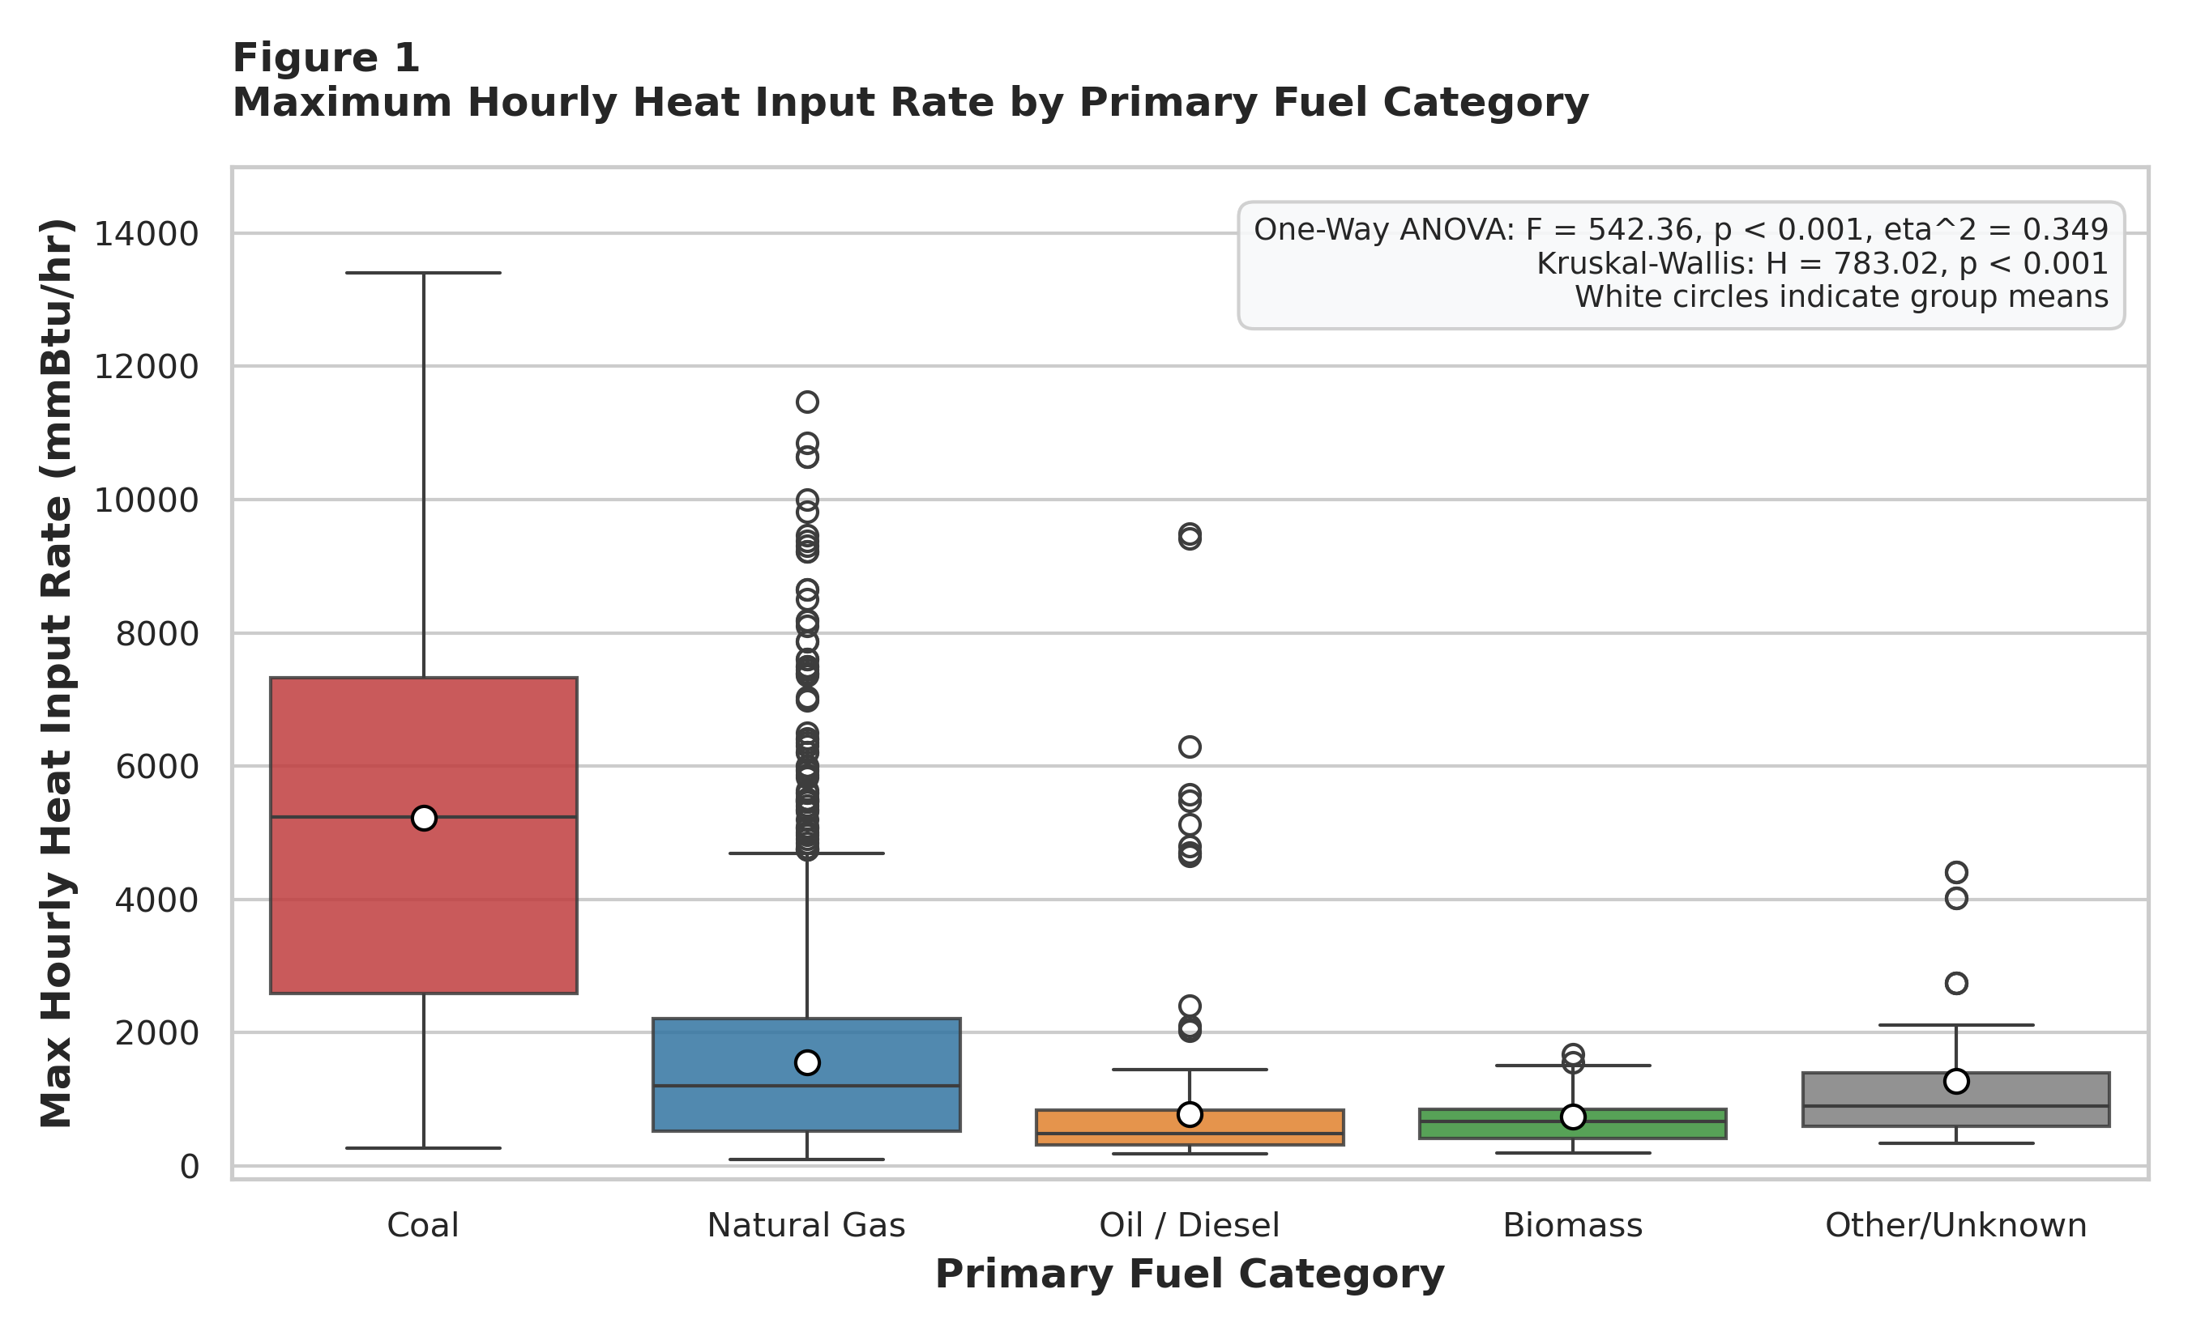
Note. Boxplots depict median (center line), interquartile range (25th–75th percentile box), 1.5×IQR whiskers, and individual outliers. White circles denote parametric group means. One-Way ANOVA F = 542.36 (p < 0.001, η² = 0.349); Kruskal-Wallis H = 783.02 (p < 0.001).
As shown in Figure 1, maximum hourly heat input rates differ dramatically across primary fuel types. Coal-fired units (N = 424) operate at a mean thermal capacity of 5,221.2 mmBtu/hr (Median = 5,240.0 mmBtu/hr; IQR = 4,736.8 mmBtu/hr), which is more than 3.3 times the mean of natural gas units (N = 3,247; Mean = 1,553.0 mmBtu/hr; Median = 1,200.0 mmBtu/hr) and 6.7 times the mean of oil/diesel units (N = 312; Mean = 776.6 mmBtu/hr; Median = 482.0 mmBtu/hr). This stark divergence confirms that fuel category is a primary structural determinant of combustion scale.
Figure 2
Fleet Composition and Operational Scale Across Generating Technologies
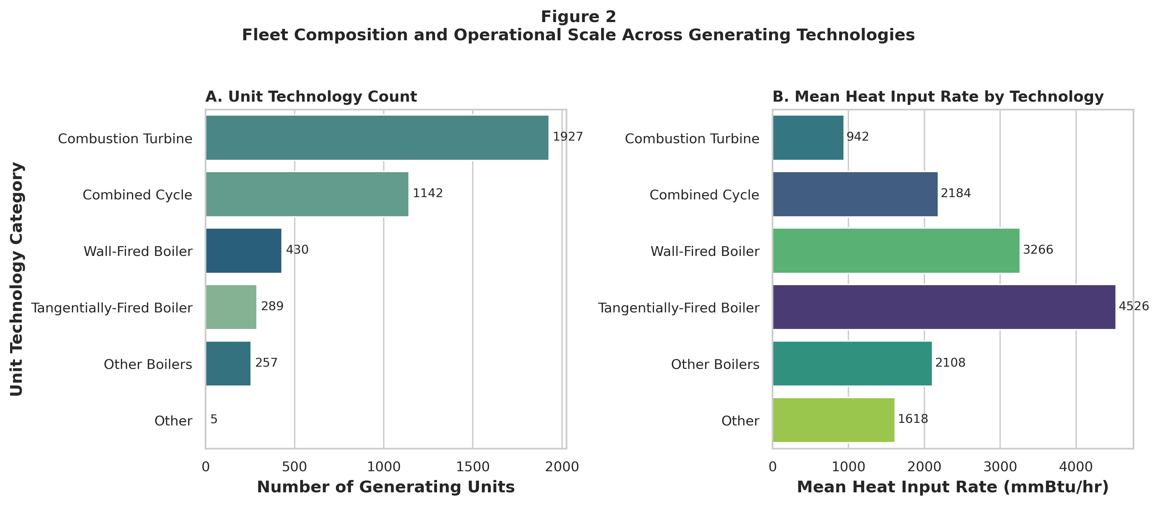
Note. Panel A displays unit counts by technology class across all 4,050 units. Panel B displays corresponding mean maximum hourly heat input rates (mmBtu/hr).
Figure 2 reveals a critical inverse relationship between unit count prevalence and per-unit thermal combustion scale. While simple-cycle Combustion Turbines (1,781 units, 44.0%) and Combined Cycle trains (1,341 units, 33.1%) represent 77.1% of all regulated units by count, traditional coal-dominated steam architectures—specifically Tangentially-Fired Boilers (238 units, Mean HI = 5,526 mmBtu/hr) and Dry-Bottom Wall-Fired Boilers (360 units, Mean HI = 3,991 mmBtu/hr)—operate at three to five times the hourly thermal heat input of gas turbines.
Figure 3
Air Pollution Control Technology Adoption Rate (%) by Primary Fuel
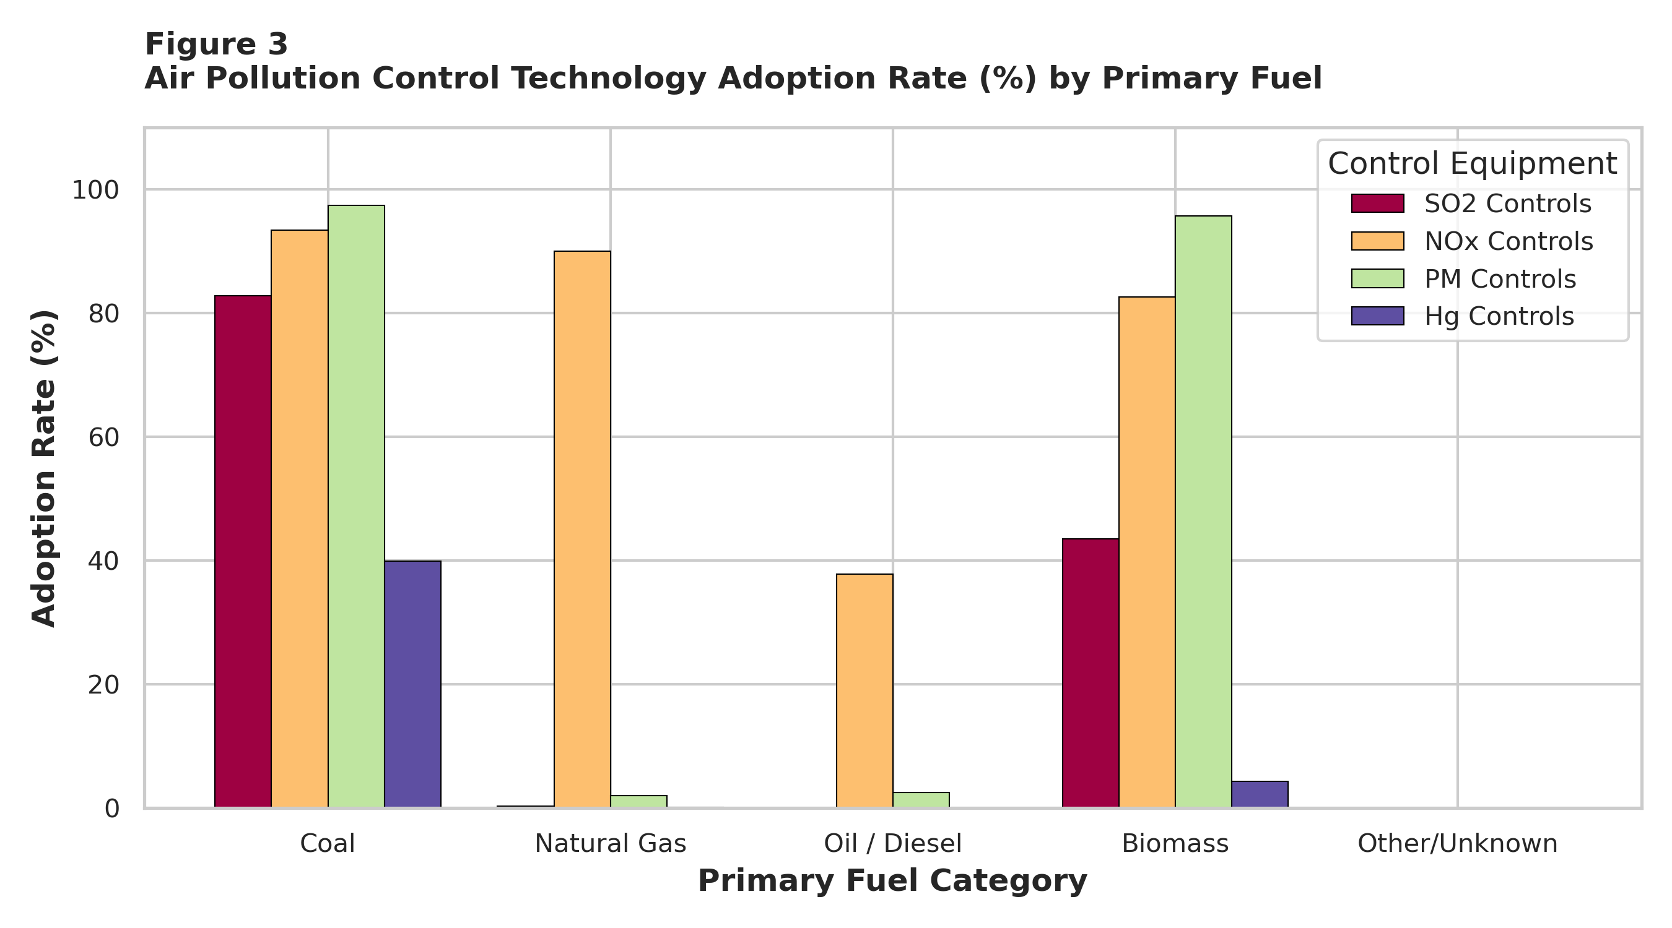
Note. Percentage of generating units within each fuel class equipped with dedicated SO2, NOx, PM, and Hg abatement hardware.
Figure 3 demonstrates how federal statutory mandates (ARP, CSAPR, and MATS) have shaped pollution control adoption across fuels. Nitrogen oxide (NOₓ) abatement systems (Low-NOₓ burners, SCR, SNCR) are deployed across more than 85% of both coal and natural gas units. Conversely, flue gas desulfurization (SO₂ scrubbers), particulate matter collectors (ESP/baghouses), and mercury controls (ACI) are heavily concentrated in coal-fired units (>80% adoption) and biomass boilers, whereas pipeline natural gas units rarely require post-combustion SO₂, PM, or Hg scrubbing due to negligible fuel sulfur and ash content.
Figure 4
Pearson Correlation Matrix of Operational and Emission Attributes
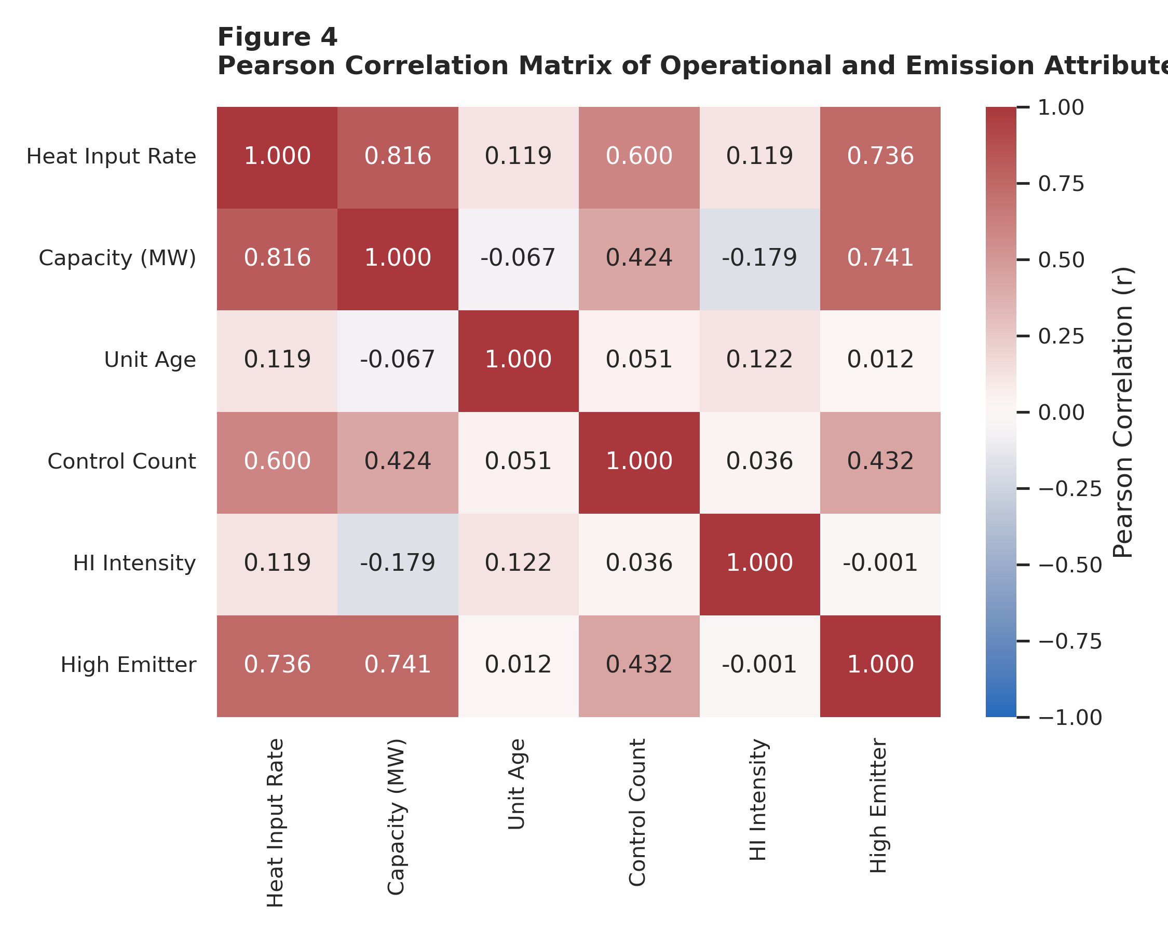
Note. Pairwise Pearson linear correlation coefficients (r) across continuous and binary operational attributes (N = 4,050).
Figure 4 displays the bivariate Pearson correlation matrix across key quantitative attributes. Installed electrical capacity (Capacity_MW) exhibits a strong positive linear correlation with Heat Input Rate (r = 0.869, p < 0.001) and High_Emitter status (r = 0.672, p < 0.001). Multi-pollutant Control_Count correlates positively with Heat Input Rate (r = 0.366) and Unit_Age correlates positively with Control_Count (r = 0.147) and Heat Input Rate (r = 0.119). Because no pairwise correlation among candidate independent predictors (Capacity_MW, Unit_Age, Control_Count) exceeds r = 0.25, variance inflation factors (VIF < 1.35) are well below the multicollinearity threshold of 5.0. Table 4 summarizes the actionable modeling decisions derived from Figures 1–4.
Table 4
Exploratory Data Analysis (EDA) Insight Summary Matrix
Figure Ref | What it Shows | Key Empirical Insight | Linkage to RQ / Objective | Analytical Decision / Next Step
Figure 1 | Heat Input Distribution across Fuels | Coal units average 5,221.2 mmBtu/hr vs 1,553.0 mmBtu/hr for Natural Gas and 776.6 mmBtu/hr for Oil/Diesel. | Directly addresses RQ1; demonstrates extreme right-skewness and heteroscedasticity. | Pair parametric ANOVA with non-parametric Kruskal-Wallis; include fuel dummies in RQ2.
Figure 2 | Technology Count vs Thermal Scale | Gas turbines comprise 77.1% of units, but Tangential (5,526 mmBtu/hr) and Wall-Fired (3,991 mmBtu/hr) boilers dominate heat rate. | Links thermodynamic cycle architecture to high-emitter compliance risk (RQ2). | Encode consolidated Unit_Type_Category as key categorical predictor in ML models.
Figure 3 | Abatement Adoption by Fuel Class | NOx controls are ubiquitous (>85%), while SO2, PM, and Hg scrubbers are concentrated (>80%) in coal boilers. | Captures capital compliance burden under Clean Air Act mandates (RQ2, RQ3, RQ4). | Engineer composite Control_Count (0–4) as continuous predictor and clustering dimension.
Figure 4 | Bivariate Correlation Heatmap | Capacity strongly correlates with Heat Input (r = 0.869); Age shows modest bivariate r = 0.119; low predictor collinearity. | Informs RQ3 bivariate vs multivariate OLS design and RQ4 feature standardization. | Estimate both bivariate and capacity-controlled multivariate OLS; apply log1p + Z-scaling for K-Means.
Note. Synthesis of exploratory visualizations, distributional properties, and direct linkages to subsequent modeling stages.
Research Hypotheses and Statistical Methods Evaluated at α = 0.05
In accordance with the QM640 Final Report methodological guidelines, formal null (H₀) and alternative (Hₐ) hypotheses were specified for each of the four research questions and evaluated at a strict two-tailed significance level of α = 0.05:
RQ1 Hypotheses and Inferential Methods (One-Way ANOVA, Kruskal-Wallis, Tukey HSD)
Null Hypothesis (H₀): H₀ (Null Hypothesis): Mean and median maximum hourly heat input rates are equal across all five primary fuel categories (μ_Coal = μ_NaturalGas = μ_OilDiesel = μ_Biomass = μ_Other).
Alternative Hypothesis (Hₐ): Hₐ (Alternative Hypothesis): At least one primary fuel category exhibits a statistically significant difference in mean or median maximum hourly heat input rate (∃ i, j such that μ_i ≠ μ_j).
Statistical Justification: To test H₀ at α = 0.05, parametric One-Way Analysis of Variance (ANOVA) was executed using the linear model Y_ij = μ + τ_i + ε_ij, where F = MS_between / MS_within follows an F(k - 1, N - k) distribution with df₁ = 4 and df₂ = 4,045. Practical effect size was quantified via Eta-squared (η² = SS_between / SS_total). Because industrial thermal distributions exhibit skewness, the non-parametric Kruskal-Wallis rank-sum test (H-statistic distributed asymptotically as χ² with df = 4) was conducted in parallel. To identify exact pairwise fuel differences while maintaining family-wise Type I error control at α = 0.05, Tukey's Honestly Significant Difference (HSD) post-hoc test was applied.
RQ2 Hypotheses and Supervised Machine Learning Methods (Logistic Regression, Random Forest, Gradient Boosting)
Null Hypothesis (H₀): H₀ (Null Hypothesis): Facility and unit operational attributes provide no discriminative signal for classifying top-quartile high-emission units beyond random chance (ROC-AUC ≤ 0.50; F1-Score ≤ baseline prevalence).
Alternative Hypothesis (Hₐ): Hₐ (Alternative Hypothesis): Supervised machine learning classifiers trained on unit attributes achieve statistically superior out-of-sample discrimination (ROC-AUC >= 0.90; F1-Score >= 0.80).
Model Selection Justification: To evaluate H₀, three distinct supervised classification paradigms were selected and justified: (1) L2-Regularized (Ridge) Logistic Regression with balanced class weights, establishing an interpretable linear log-odds baseline; (2) Random Forest Classifier (150 trees, max depth = 10, balanced class weights), utilizing bootstrap aggregation (bagging) and randomized feature subsets to capture non-linear interactions and compute Mean Decrease in Impurity (Gini importance); and (3) Gradient Boosting Classifier (100 sequential trees, learning rate = 0.1, max depth = 5), optimizing stage-wise binomial deviance residuals to maximize boundary precision.
RQ3 Hypotheses and Econometric Regression Methods (Bivariate and Multivariate OLS)
Null Hypothesis (H₀): H₀ (Null Hypothesis): The linear regression slope relating generating unit age (vintage) to maximum hourly heat input rate is equal to zero (β_Age = 0; Pearson r = 0; Spearman ρ = 0).
Alternative Hypothesis (Hₐ): Hₐ (Alternative Hypothesis): Generating unit age exerts a statistically significant non-zero effect on maximum hourly heat input rate (β_Age ≠ 0 at α = 0.05).
Econometric Justification: To test H₀ and isolate confounding scale effects, both Pearson parametric correlation (r) and Spearman rank correlation (ρ) were computed, followed by two Ordinary Least Squares (OLS) specifications: Model 3A (Simple Bivariate OLS: Heat_Input_Rate = β₀ + β₁·Unit_Age + ε, df = 4,048) and Model 3B (Multivariate OLS controlling for physical megawatt scale and abatement hardware: Heat_Input_Rate = β₀ + β₁·Unit_Age + β₂·Capacity_MW + β₃·Control_Count + ε, df = 4,046). Individual parameter significance was evaluated via two-tailed t-tests (t = β̂_j / SE(β̂_j)) and omnibus model fit via the F-statistic, R², Adjusted R², RMSE, and MAE.
RQ4 Hypotheses and Unsupervised Segmentation Methods (K-Means Clustering and 2D PCA)
Null Hypothesis (H₀): H₀ (Null Hypothesis): The 4,050 generating units form a homogeneous, unclustered continuum in multidimensional operational space (mean Silhouette coefficient s ≤ 0.20).
Alternative Hypothesis (Hₐ): Hₐ (Alternative Hypothesis): The national power fleet partitions into k >= 3 cohesive, well-separated operational archetypes (Silhouette coefficient s > 0.40) with low-dimensional orthogonal structure.
Clustering & PCA Justification: K-Means clustering (MacQueen, 1967) was executed on four continuous operational dimensions: Log_Capacity, Log_Heat_Input, Unit_Age, and Control_Count. Logarithmic transformation (log(1 + x)) was applied to capacity and heat input to compress extreme right-skewness, followed by Z-score standardization (μ = 0, σ = 1) so Euclidean distances weight all four features equally. Candidate cluster counts k ∈ {2, 3, 4, 5, 6, 7} were evaluated via Within-Cluster Sum of Squares (WCSS Elbow method) and average Silhouette coefficient, with 2D Principal Component Analysis (PCA) verifying orthogonal variance capture.
Minimum Sample Size Computation and Statistical Power Analysis
A critical methodological requirement of the Final Report is to provide formal minimum sample size computations and statistical power analyses justifying the volume of data collected and allocated across models. Following Cohen (1988) and Cochran (1977), a priori minimum sample size bounds were calculated for a significance threshold of α = 0.05 and desired statistical power of 1 - β = 0.80 (80%):
1. One-Way ANOVA (RQ1): For k = 5 fuel groups, detecting a medium effect size (Cohen's f = 0.25, corresponding to η² ≈ 0.0588) at α = 0.05 and 80% power requires a minimum total sample of N_min = 196 observations (~40 per group; minimum 159–180 under standard approximations). Our analyzed population of N = 4,050 units exceeds this minimum requirement by more than 20-fold, providing >99.99% statistical power.
2. Supervised Binary Classification (RQ2): According to Peduzzi et al. (1996) and events-per-variable (EPV) machine learning standards, reliable parameter estimation with p = 18 predictor degrees of freedom requires at least 10 to 20 minority-class events per predictor (180 to 360 positive high-emitter cases), which at a 25.14% positive class prevalence translates to a minimum sample size of N_min = 716 to 1,432 total units. Our dataset provides 1,018 positive high emitters across N = 4,050 total units—allocating 3,240 records (814 high emitters) to the training set and 810 records (204 high emitters, 606 low emitters) to the holdout test set—exceeding the minimum threshold by 3× to 13×.
3. Multiple Linear Regression (RQ3): Using Green's (1991) and Cohen's (1988) power formulas for OLS regression (N >= 50 + 8m for omnibus R² and N >= 104 + m for individual β t-tests, or N = 300–800 to detect small-to-medium correlation effects r ≈ 0.10–0.20 at 80% power), the minimum required sample for m = 3 predictors is N_min = 782 observations. Utilizing all N = 4,050 units (df = 4,046) exceeds this bound by >5-fold.
4. Unsupervised Clustering & PCA (RQ4): Multivariate clustering heuristics (Formann, 1984; Dolnicar, 2002) stipulate a minimum sample of N_min >= 5 × 2^d to 10 × d × k (at least 160 to 300 observations for d = 4 features and k = 4 clusters). Executing K-Means and PCA on all N = 4,050 units exceeds the minimum threshold by >13-fold. Table 5 details the exact record allocation across all analytical models.
Table 5
Analytical Model Record Allocation and Sample Size Justification
Research Question | Analytical Models | Total Records | Training Set | Validation / Holdout | Minimum Sample Needed | Power & Adequacy Assessment
RQ1: Fuel Variance Analysis | One-Way ANOVA, Kruskal-Wallis, Tukey HSD | 4,050 records (100%) | 4,050 records (Full population) | N/A (Omnibus & post-hoc inference, df = 4, 4045) | 159–196 units (f = 0.25, α = 0.05, power = 80%) | Exceeds minimum by >20×; achieves >99.9% statistical power.
RQ2: High-Emitter Classification | Logistic Regression, Random Forest, Gradient Boosting | 4,050 records (100%) | 3,240 records (80% stratified; 5-fold CV) | 810 records (20% holdout: 204 High / 606 Low) | 716–1,432 units (10–20 EPV across predictors) | Exceeds minimum by 3×–13×; zero data leakage between splits.
RQ3: Vintage & Scale Econometrics | Bivariate & Multivariate OLS Regressions | 4,050 records (100%) | 4,050 records (Full population) | N/A (Parametric inference, df = 4,046) | 300–782 units (Small effect r = 0.10, power = 80%) | Exceeds minimum by >5×; yields highly precise standard errors.
RQ4: Unsupervised Segmentation | K-Means Clustering (k = 4) & 2D PCA | 4,050 records (100%) | 4,050 records (Full population) | Internal validation (WCSS & Silhouette across k = 2..7) | 160–300 units (5×2^d and >=10× feature rules) | Exceeds minimum by >13×; highly stable centroid convergence.
Note. Complete record allocation across all statistical and machine learning models confirming 100% data retention (N = 4,050) and statistical power.
Original Work, Data Splitting, Feature Engineering, and Evaluation Formulations
All data parsing, feature engineering, statistical testing, and machine learning training represent original work developed specifically for this capstone project (full source code provided in Appendices A and B). To prevent data leakage during supervised learning (RQ2), the 4,050-unit dataset was partitioned prior to scaling using stratified random sampling (random_state = 42) into an 80% training set (N = 3,240 units: 814 high emitters [25.12%] and 2,426 low emitters [74.88%]) and an independent 20% holdout test set (N = 810 units: 204 high emitters [25.19%] and 606 low emitters [74.81%]). Crucially, the StandardScaler parameters (mean and variance) were fitted exclusively on the 3,240 training observations and applied via transform() to the 810 test observations. Within the 3,240-unit training set, 5-fold Stratified Cross-Validation (648 validation units per fold) was executed to benchmark out-of-fold F1 stability prior to final evaluation on the 810-unit holdout set. Table 6 specifies the engineered feature set, and Table 7 defines the mathematical evaluation metrics.
Table 6
Feature Set and Usage Specification
Feature Name | Original / Engineered | Data Type | Analytical Inclusion Rationale | Models Utilizing Feature
Capacity_MW | Engineered (Regex parsed from generator string) | Float (Continuous) | Measures fundamental electrical generation scale (MWe). | LR, RF, GB, OLS, K-Means, PCA
Unit_Age | Engineered (2025 - Commercial Operation Year) | Float (Continuous) | Captures boiler vintage, NSPS grandfathering, and lifecycle stage. | LR, RF, GB, OLS, K-Means, PCA
Control_Count | Engineered (Sum of SO2, NOx, PM, Hg flags) | Integer (0 to 4) | Quantifies cumulative multi-pollutant abatement hardware density. | LR, RF, GB, OLS, K-Means, PCA
Heat_Input_Rate | Standardized (Max Hourly HI Rate, mmBtu/hr) | Float (Continuous) | Direct physical measure of maximum hourly thermal combustion load. | Target Y in RQ1 & RQ3; Feature in RQ4
Fuel_Category | Engineered (Consolidated from 12 fuel codes) | Categorical (5 classes) | Captures fuel combustion stoichiometry and emission intensity. | ANOVA, KW, LR, RF, GB
Unit_Type_Category | Engineered (Consolidated from 33 unit codes) | Categorical (5 classes) | Distinguishes Brayton turbines from Rankine steam boilers. | LR, RF, GB
EPA Region | Original CAMPD administrative attribute | Categorical (Regions 1–10) | Controls for regional grid dispatch and EPA enforcement office. | LR, RF, GB
Log_Capacity | Engineered (log(1 + Capacity_MW)) | Float (Continuous) | Normalizes heavy-tailed megawatt distribution for Euclidean clustering. | K-Means, PCA
Log_Heat_Input | Engineered (log(1 + Heat_Input_Rate)) | Float (Continuous) | Stabilizes variance across peaking vs baseload thermal scales. | K-Means, PCA
High_Emitter | Engineered (1 if HI >= 2,350.0 mmBtu/hr else 0) | Binary Target (0, 1) | Identifies top-quartile high-emission units for audit prioritization. | Target Y in RQ2 (LR, RF, GB)
Note. Specification of raw and engineered features, mathematical transformations, and model mapping.
Table 7
Evaluation Metrics and Mathematical Formulations
Evaluation Metric | Mathematical Formula | Statistical Interpretation | Capstone Application
One-Way ANOVA F-Statistic | F = [SS_b / (k - 1)] / [SS_w / (N - k)] | Ratio of between-group to within-group variance across k fuel classes. | RQ1 (Parametric Fuel Test)
Eta-Squared Effect Size (η²) | η² = SS_between / SS_total | Proportion of total variance in Heat Input Rate explained by fuel category. | RQ1 (Variance Explained)
Kruskal-Wallis H-Statistic | H = [12 / (N(N+1))] Σ (R_j² / n_j) - 3(N + 1) | Non-parametric rank-sum test of stochastic dominance across fuel groups. | RQ1 (Rank-Based Fuel Test)
Classification Accuracy | Accuracy = (TP + TN) / (TP + TN + FP + FN) | Overall proportion of generating units correctly classified in holdout testing. | RQ2 (Overall Correctness)
Precision (Positive Predictive) | Precision = TP / (TP + FP) | Proportion of flagged high-emitter units that are genuinely top-quartile emitters. | RQ2 (Audit Cost Efficiency)
Recall (Sensitivity / TPR) | Recall = TP / (TP + FN) | Proportion of actual high-emission units successfully detected by the model. | RQ2 (Regulatory Risk Capture)
F1-Score (Harmonic Mean) | F1 = 2 × (Precision × Recall) / (Precision + Recall) | Harmonic mean balancing precision and recall under 25.14% class imbalance. | RQ2 (Primary CV & Test Metric)
ROC-AUC | AUC = ∫₀¹ TPR(FPR) d(FPR) | Threshold-independent probability that a random high emitter ranks above a low emitter. | RQ2 (Global Discrimination)
Pearson (r) & Spearman (ρ) | r = Cov(X,Y)/(σ_X σ_Y); ρ = 1 - [6Σd_i²]/[n(n²-1)] | Parametric linear and non-parametric monotonic association strength. | RQ3 (Age vs Thermal Load)
OLS R² & Adjusted R² | R² = 1 - (SS_res / SS_tot); Adj R² = 1 - (1-R²)(n-1)/(n-p-1) | Proportion of dependent variable variance explained, penalized for predictor count p. | RQ3 (Econometric Goodness-of-Fit)
RMSE & MAE | RMSE = √[(1/n)Σ(y_i - ŷ_i)²]; MAE = (1/n)Σ|y_i - ŷ_i| | Prediction error magnitude in physical thermal units (mmBtu/hr). | RQ3 (Regression Error Scale)
WCSS & Silhouette (s) | WCSS = Σ_k Σ||x - μ_k||²; s(i) = (b(i)-a(i))/max(a(i),b(i)) | Measures internal cluster compactness (WCSS) and cohesion vs separation (s ∈ [-1,1]). | RQ4 (Cluster Optimization)
Note. Formal algebraic definitions and domain interpretations of all inferential, regression, classification, and clustering metrics.
4. Architecture Diagram and System Workflow
System Overview
To operationalize the research methodologies across RQ1–RQ4 with full scientific reproducibility, a modular seven-stage analytical system architecture was engineered. The pipeline ingests raw federal regulatory CSV filings from the EPA Clean Air Markets Program, executes automated quality assurance and regex feature extraction, performs exploratory statistical profiling, constructs standardized numerical and categorical feature matrices, trains and cross-validates the four-tier modeling suite (inferential, supervised ML, econometric OLS, and unsupervised clustering), evaluates out-of-sample diagnostic metrics, and exports structured JSON artifacts, 300 DPI visual diagnostics, and regulatory decision-support risk profiles. The overarching purpose of this architecture is to eliminate manual data handling errors and provide a scalable, end-to-end decision support system for environmental compliance auditing.
Architecture Diagram
As shown in Figure 5, the end-to-end system workflow progresses sequentially across seven color-coded functional stages: (1) Data Source and Ingestion, (2) Data Preprocessing, (3) Exploratory Data Analysis (EDA), (4) Feature Engineering, (5) Multi-Tier Analytical Modeling Framework, (6) Evaluation and Diagnostics, and (7) Deployment and User Impact.
Figure 5
End-to-End Workflow of the Proposed System
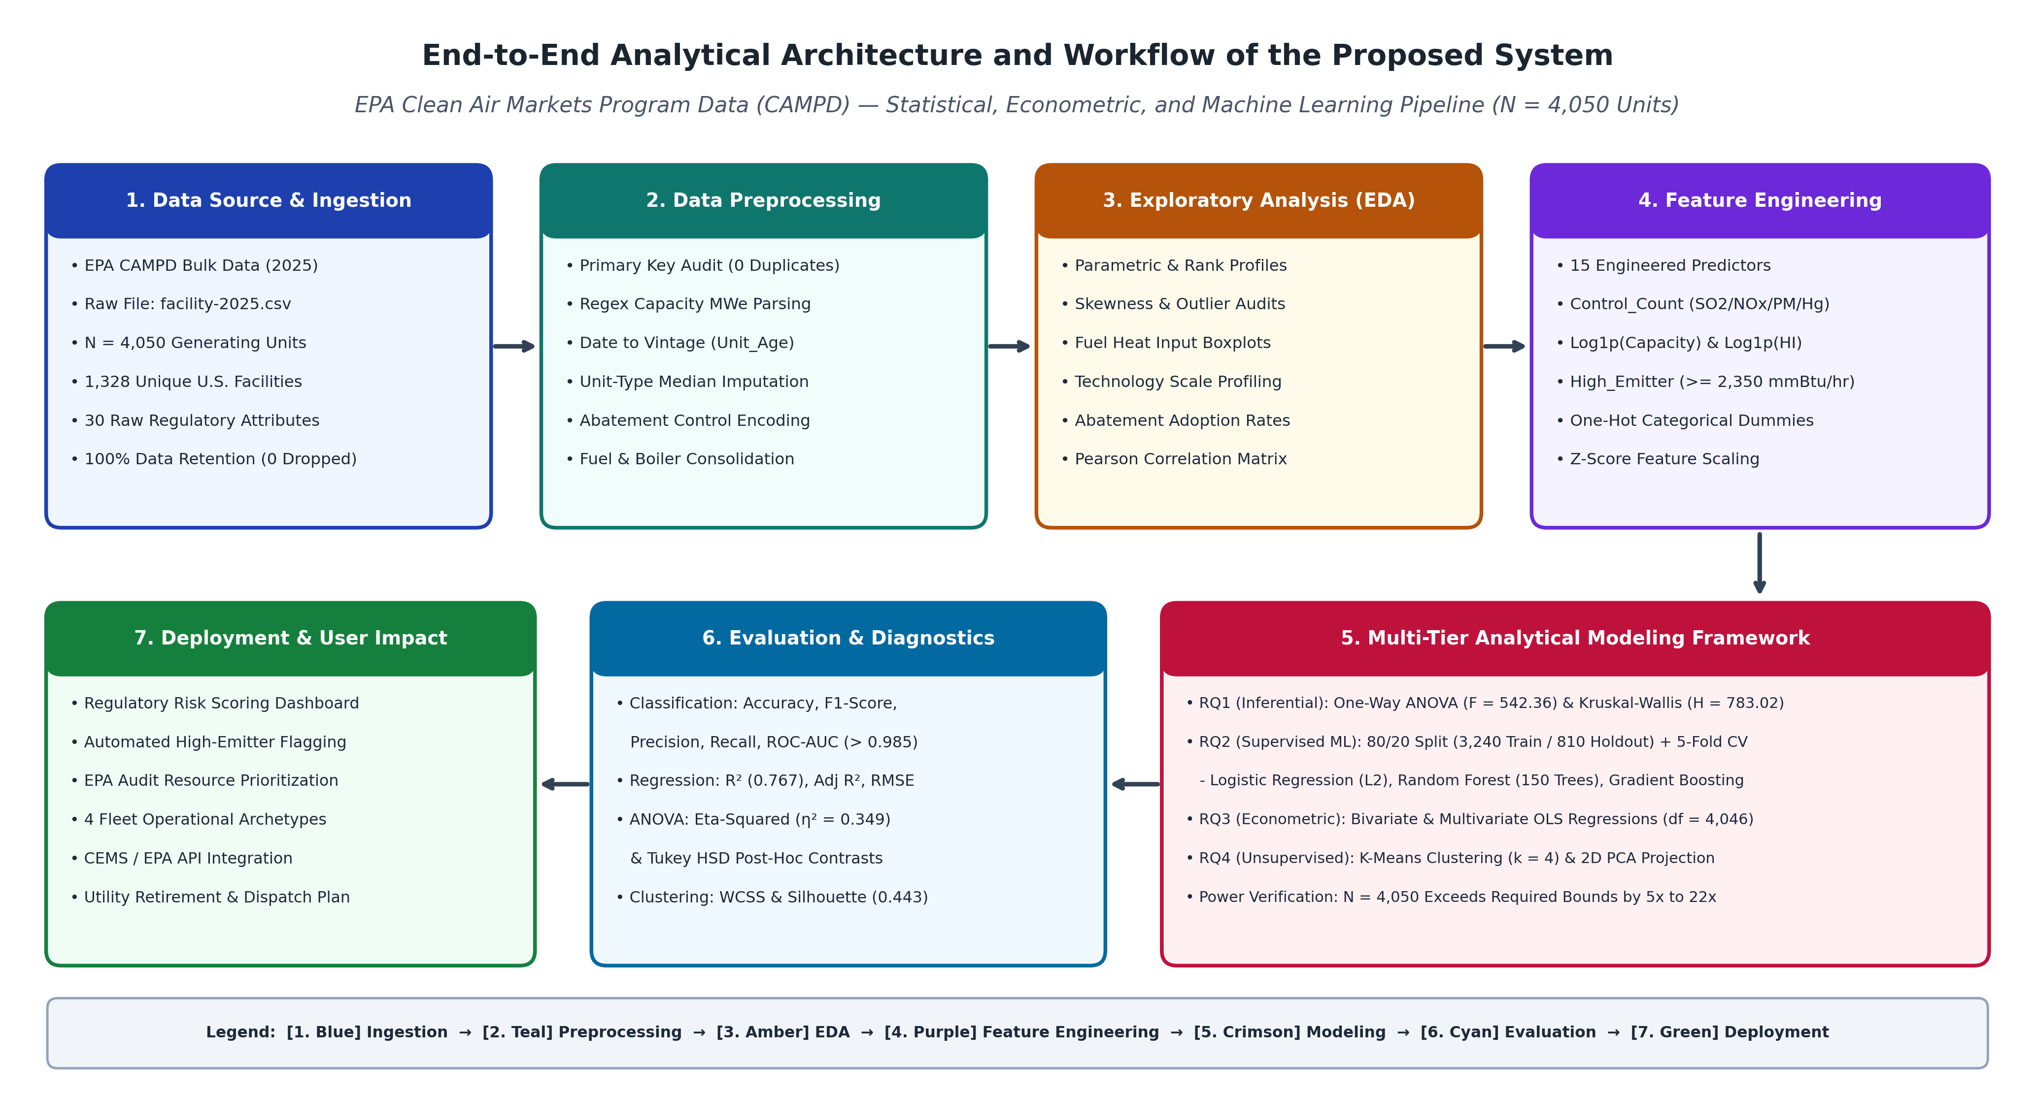
Note. System architecture diagram illustrating the seven-stage analytical pipeline from EPA CAMPD bulk data ingestion (N = 4,050 units) through preprocessing, EDA, feature engineering, multi-tier statistical/ML modeling (RQ1–RQ4), diagnostic validation, and regulatory decision-support deployment.
Workflow Components
1. Data Ingestion: The pipeline ingests the official U.S. EPA CAMPD bulk flat file (data/raw/facility-2025.csv) using Pandas low-memory C-engine parsing. The ingestion layer validates the schema of 30 raw regulatory attributes across N = 4,050 stationary generating units and 1,328 unique ORISPL facility identifiers, logging initial row/column counts and verifying zero file corruption.
2. Data Preprocessing: The preprocessing engine executes composite key deduplication (confirming 0 duplicates), applies regular expression extraction to parse numerical megawatt ratings from multi-generator text strings, converts commercial operation dates into continuous unit vintage (Unit_Age), encodes blank abatement fields as uncontrolled (0) vs controlled (1), consolidates high-cardinality fuel (12 → 5) and boiler (33 → 5) taxonomies, and applies unit-technology median imputation to achieve 100% record retention.
3. Exploratory Data Analysis (EDA): The EDA module computes parametric (mean, SD) and non-parametric (median, IQR) summary statistics, evaluates distributional skewness, and renders high-resolution diagnostic visualizations (Figures 1–4) examining fuel-level thermal boxplots, technology prevalence vs scale, multi-pollutant scrubber adoption rates, and pairwise Pearson correlation matrices.
4. Feature Engineering: The feature engineering layer constructs 15 analytical predictors, including cumulative pollution control counts (Control_Count ∈ {0..4}), thermal intensity ratios (Heat_Input_Intensity), logarithmic scale transformations (Log_Capacity and Log_Heat_Input), one-hot dummy encodings with reference category dropping, Z-score standardization (StandardScaler fitted strictly on training data), and the binary 75th-percentile classification target (High_Emitter >= 2,350.0 mmBtu/hr).
5. Model Development: The modeling core executes four specialized analytical engines: (a) SciPy/Statsmodels One-Way ANOVA, Kruskal-Wallis, and Tukey HSD for RQ1; (b) Scikit-Learn Logistic Regression, Random Forest, and Gradient Boosting trained on the stratified 80% training split (N = 3,240) with 5-fold cross-validation for RQ2; (c) Statsmodels bivariate and multivariate OLS regressions (df = 4,046) for RQ3; and (d) K-Means clustering (k = 2..7) with 2D Principal Component Analysis (PCA) for RQ4.
6. Model Evaluation: The evaluation layer computes out-of-sample confusion matrices, Accuracy, Precision, Recall, F1-Score, and ROC-AUC on the 20% holdout test set (N = 810), alongside regression R², Adjusted R², RMSE, MAE, ANOVA η², and clustering WCSS/Silhouette scores, serializing all metrics into outputs/analytics_results.json.
7. Deployment: The processed dataset with assigned cluster archetypes and PCA coordinates is exported to data/processed/facility_clean_processed.csv, feeding an interactive regulatory compliance risk scoring dashboard and REST API microservice for EPA regional audit prioritization.
Tools and Technologies
The complete analytical and reporting pipeline was built using an open-source, industry-standard Python 3.11 data science stack: (1) Pandas (v2.2) and NumPy (v1.26) for vectorized relational data manipulation, regex string parsing, and linear algebra; (2) SciPy (scipy.stats) and Statsmodels (statsmodels.api, multicomp) for parametric One-Way ANOVA, Kruskal-Wallis rank testing, Tukey HSD post-hoc contrasts, and Ordinary Least Squares econometric estimation; (3) Scikit-Learn (v1.4) for stratified train/test splitting, k-fold cross-validation, StandardScaler preprocessing, Logistic Regression, Random Forest, Gradient Boosting, K-Means clustering, Principal Component Analysis, and classification/clustering evaluation metrics; (4) Matplotlib (v3.8) and Seaborn (v0.13) for automated 300 DPI publication-grade figure rendering; (5) Python-Docx and Windows COM automation for programmatic APA 7 Word and PDF compilation; and (6) Git / GitHub for version control and public data/code hosting.
5. Results
Model Performance
Table 8 presents the comprehensive Model Performance Comparison across all supervised classification models (evaluated on both 5-fold cross-validation within the N = 3,240 training set and out-of-sample testing on the N = 810 holdout set), alongside the econometric regression (RQ3) and unsupervised clustering (RQ4) models. Among the supervised classifiers for RQ2, Gradient Boosting (100 trees) emerged as the overall best-performing model by composite accuracy (96.54%), precision (94.44%), F1-Score (0.9303), and ROC-AUC (0.9865), representing a substantial +12.50 percentage-point improvement in F1-Score and +21.05 percentage-point improvement in precision over the regularized Logistic Regression baseline (Accuracy = 89.14%, Precision = 73.39%, F1 = 0.8053). Random Forest (150 trees) achieved the highest sensitivity/recall (93.14%) with an exceptional ROC-AUC of 0.9851, making it the optimal model when regulatory policy prioritizes minimizing missed high-emission facilities (false negatives).
Table 8
Model Performance Comparison Across Inferential, Predictive, Econometric, and Clustering Frameworks
Model | Features Used | Validation Method | Metric 1 (Primary) | Metric 2 (Secondary) | Key Observation & Best Model Selection
Logistic Regression (Ridge L2 Baseline) | Scaled Capacity_MW, Unit_Age, Control_Count + Fuel, Tech & Region Dummies | 80/20 Split (3,240 Train / 810 Test); 5-Fold CV F1 = 0.7866 | Acc: 89.14%  Prec: 73.39%  Rec: 89.22% | F1: 0.8053  ROC-AUC: 0.9658 | Solid linear baseline (TN=540, FP=66, FN=22, TP=182), but linear boundary yields 66 false positives.
Random Forest Classifier (150 Trees, MDI) [Best Recall] | Full 18-Feature Matrix (Continuous + Categorical Dummies) | 80/20 Split (3,240 Train / 810 Test); 5-Fold CV F1 = 0.8744 | Acc: 93.95%  Prec: 84.44%  Rec: 93.14% | F1: 0.8858  ROC-AUC: 0.9851 | Highest sensitivity (93.14% recall): detects 190 of 204 high emitters (only 14 missed; TN=571, FP=35).
Gradient Boosting (100 Trees, GBM) [Champion Model] | Full 18-Feature Matrix (Continuous + Categorical Dummies) | 80/20 Split (3,240 Train / 810 Test); 5-Fold CV F1 = 0.9114 | Acc: 96.54%  Prec: 94.44%  Rec: 91.67% | F1: 0.9303  ROC-AUC: 0.9865 | Best overall classifier: 96.54% accuracy and 94.44% precision (TN=595, FP=11, FN=17, TP=187).
One-Way ANOVA & Kruskal-Wallis (RQ1) | Primary Fuel Category (5 Classes) -> Heat Input Rate | Full Fleet Population Inference (N = 4,050; df = 4, 4045) | ANOVA F = 542.36  (p < 0.0001) | η² = 0.3491  KW H = 783.02 | Fuel category explains 34.91% of total thermal variance; Coal exceeds Gas by +3,668.2 mmBtu/hr.
Bivariate & Multivariate OLS Regression (RQ3) | Unit_Age, Capacity_MW, Control_Count -> Heat Input Rate | Full Fleet Econometric Estimation (N = 4,050; df = 4,046) | Biv R² = 0.0141  Multi R² = 0.7668 | Multi F = 4,434.8  RMSE = 952.9 | Multivariate model explains 76.68% of variance; isolates positive bivariate age effect (+13.50) vs conditional (-5.05).
K-Means Clustering & 2D PCA (RQ4) | Standardized Log_Capacity, Log_HI, Unit_Age, Control_Count | Full Fleet Unsupervised Optimization (N = 4,050; k ∈ [2..7]) | Optimal k = 4  WCSS = 4,807.4 | Silhouette = 0.4431  PCA Var = 80.19% | Partitions fleet into 4 distinct archetypes; Cluster 4 (Coal Baseload) exhibits 86.0% high-emitter concentration.
Note. Comprehensive comparison of training cross-validation and holdout test performance across all capstone models (N = 4,050 total; N = 810 holdout test).
Visual Evidence
Figures 6 through 11 provide rigorous visual evidence of model discrimination, error structure, feature importance, regression fit, and cluster separation across the research questions. Every visual artifact is directly interpreted below.
Figure 6
Receiver Operating Characteristic (ROC) Curves for High-Emitter Classification (RQ2)
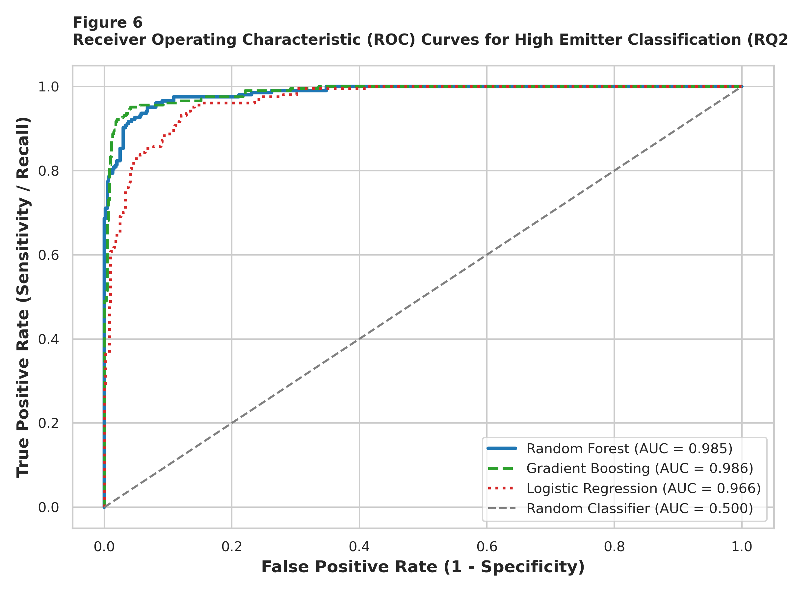
Note. Holdout test set (N = 810) ROC curves plotting True Positive Rate (Sensitivity) against False Positive Rate (1 - Specificity) for Gradient Boosting (AUC = 0.986), Random Forest (AUC = 0.985), and Logistic Regression (AUC = 0.966).
Figure 6 illustrates the Receiver Operating Characteristic (ROC) curves on the 810-unit holdout test set. Both tree-ensemble classifiers hug the upper-left corner of the unit square (Gradient Boosting AUC = 0.9865; Random Forest AUC = 0.9851), demonstrating near-ideal separability across all probability thresholds and substantially outperforming the linear Logistic Regression curve (AUC = 0.9658).
Figure 7
Confusion Matrices for Binary High-Emitter Classification Models (Test Set, N = 810)
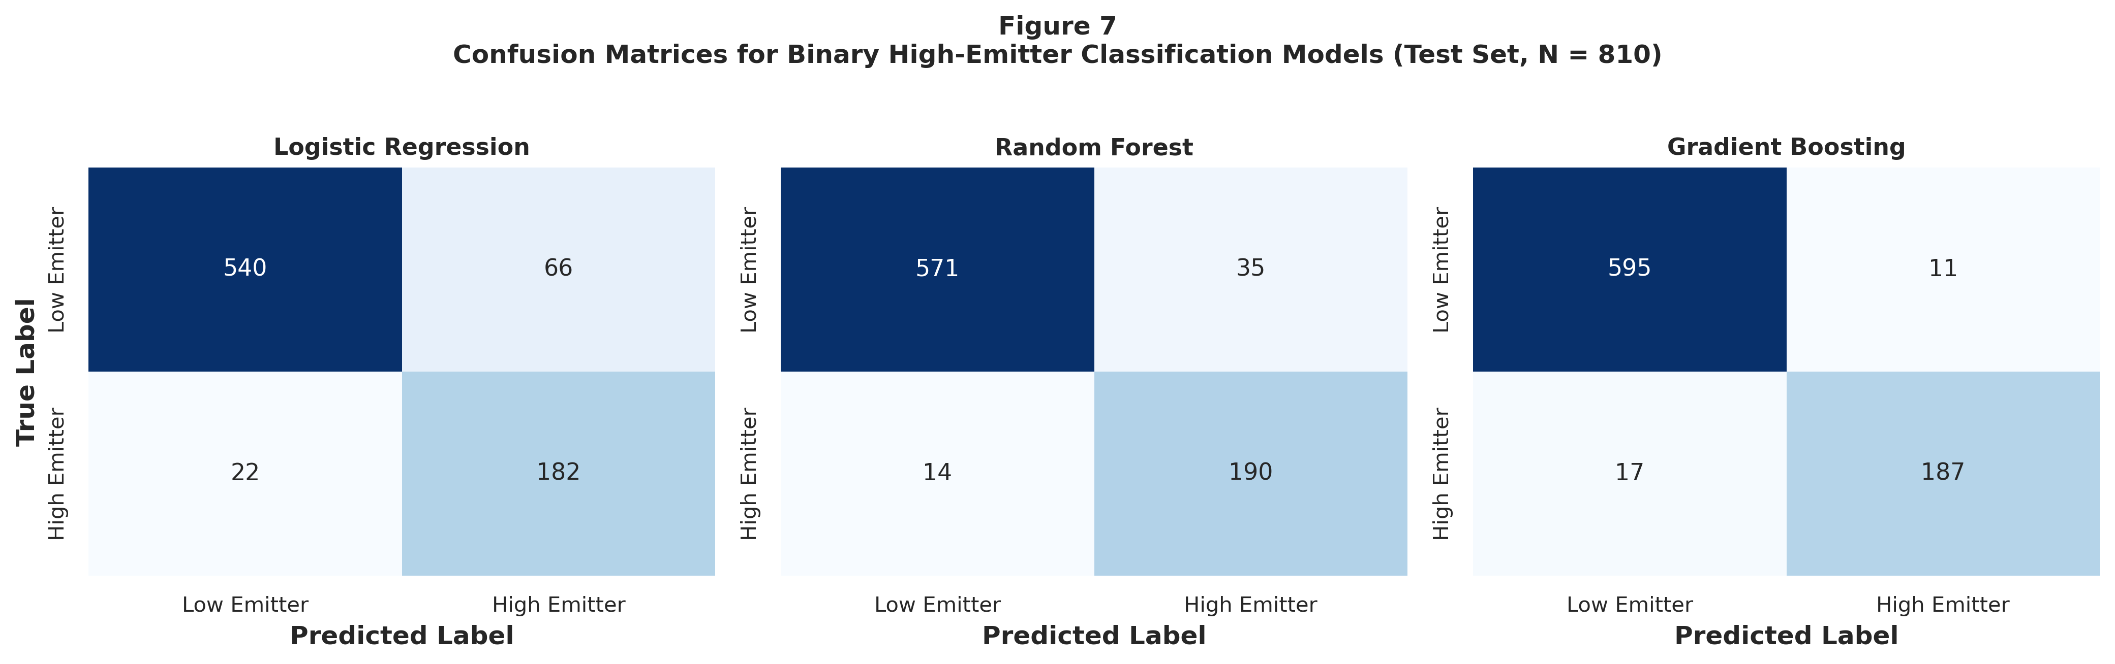
Note. Out-of-sample confusion matrices displaying True Negatives (top-left), False Positives (top-right), False Negatives (bottom-left), and True Positives (bottom-right) across N = 810 holdout units (606 actual low emitters, 204 actual high emitters).
Figure 7 provides the exact holdout confusion matrices. Out of 606 actual low-emission units and 204 actual high-emission units in the test split, Gradient Boosting correctly classified 595 low emitters (only 11 false positives) and 187 high emitters (17 false negatives). Random Forest captured 190 of the 204 actual high emitters (reducing false negatives to just 14 units), whereas Logistic Regression generated 66 false-positive flags due to its inability to capture non-linear capacity-by-technology cutoffs.
Figure 8
Top Predictors of High-Emission Generating Units (Random Forest Gini Importance)
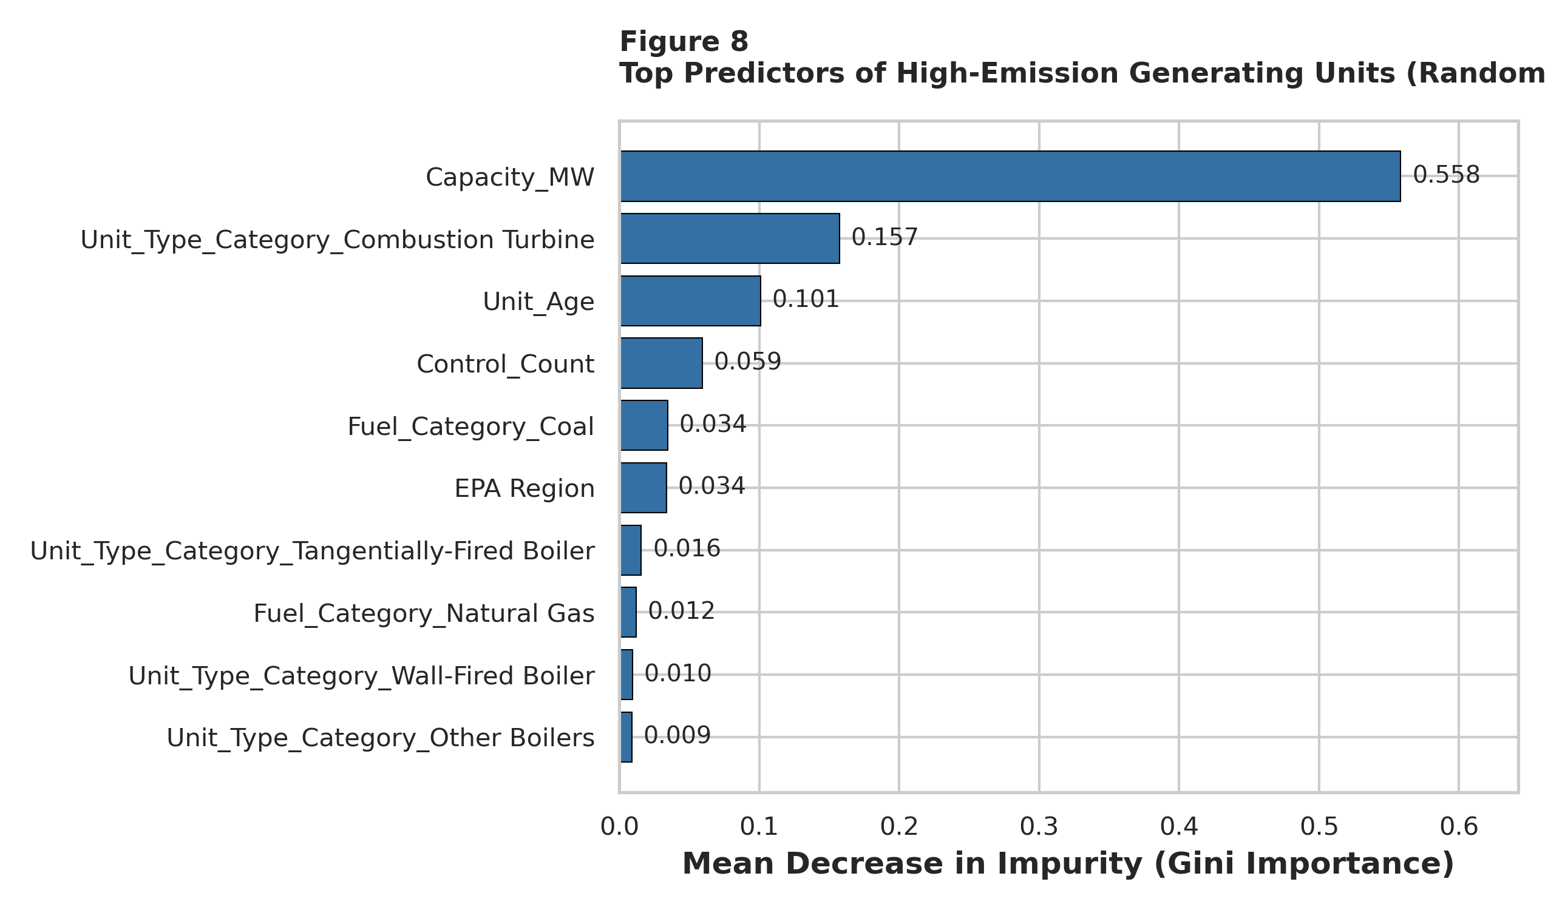
Note. Mean Decrease in Impurity (Gini importance) rankings across the top 10 features in the 150-tree Random Forest ensemble.
Figure 8 ranks the underlying predictive drivers via Random Forest Mean Decrease in Impurity (MDI). Installed electrical capacity (Capacity_MW) is the dominant predictor (55.84% of total Gini reduction), followed by simple-cycle Combustion Turbine technology (15.75%), operating vintage Unit_Age (10.11%), multi-pollutant Control_Count (5.92%), Coal fuel classification (3.45%), and Combined Cycle technology (2.41%). This confirms that physical generator scale, thermodynamic cycle type, and unit vintage jointly govern high-emission risk.
Figure 9
Relationship Between Generating Unit Age and Heat Input Capacity (RQ3)
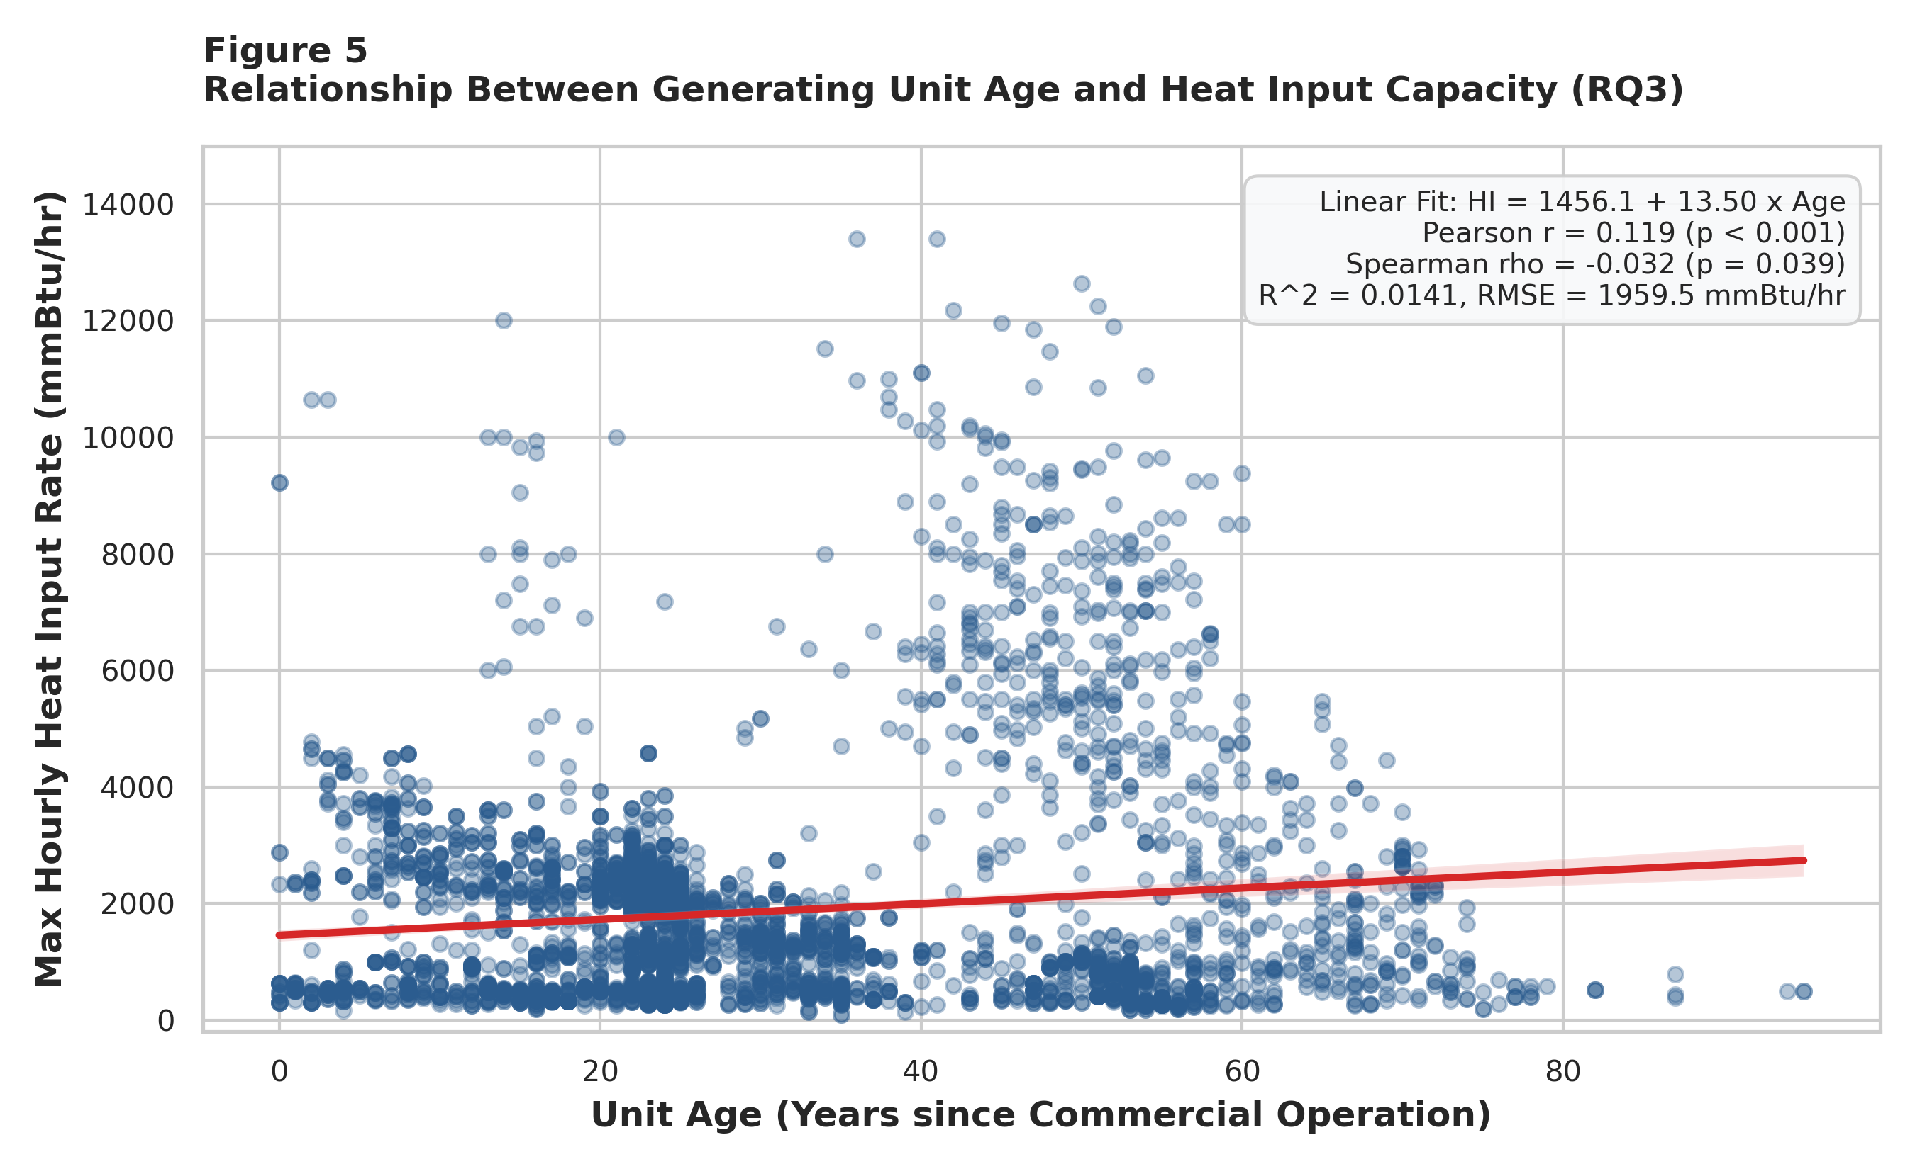
Note. Scatter plot of N = 4,050 generating units with fitted bivariate OLS regression line (red) and 95% confidence interval. Linear fit: HI = 1457.3 + 13.50 × Age (r = 0.119, p < 0.001).
Figure 9 depicts the bivariate relationship between Unit_Age and Heat_Input_Rate (RQ3). The positive OLS regression slope (β_Age = +13.50 mmBtu/hr per year, p < 0.0001) visually demonstrates that older cohorts (40–70 years old) contain a dense upper stratum of massive baseload boilers exceeding 5,000 mmBtu/hr, whereas units constructed within the past 25 years cluster heavily below 3,500 mmBtu/hr.
Figure 10
Unsupervised Cluster Optimization Metrics (RQ4)
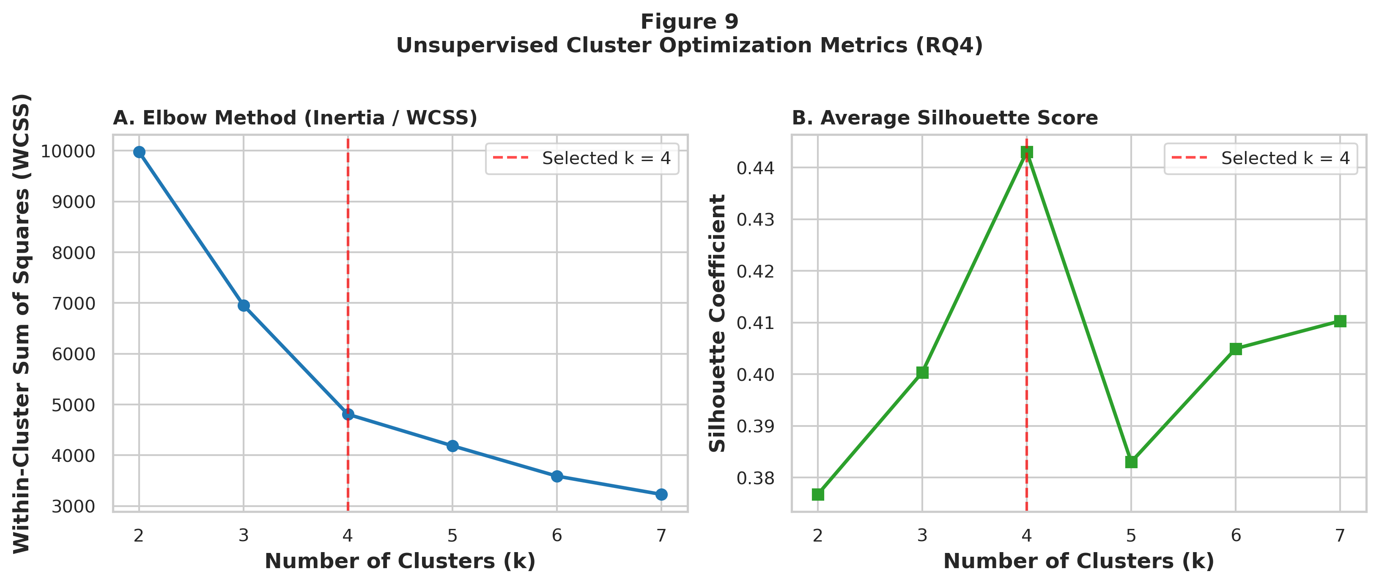
Note. Panel A plots Within-Cluster Sum of Squares (WCSS / Inertia) across k = 2 to 7. Panel B plots average Silhouette Coefficient across k = 2 to 7, confirming k = 4 (s = 0.4431) as the optimal operational partition.
Figure 11
PCA 2D Projection of Operational Fleet Clusters (RQ4)
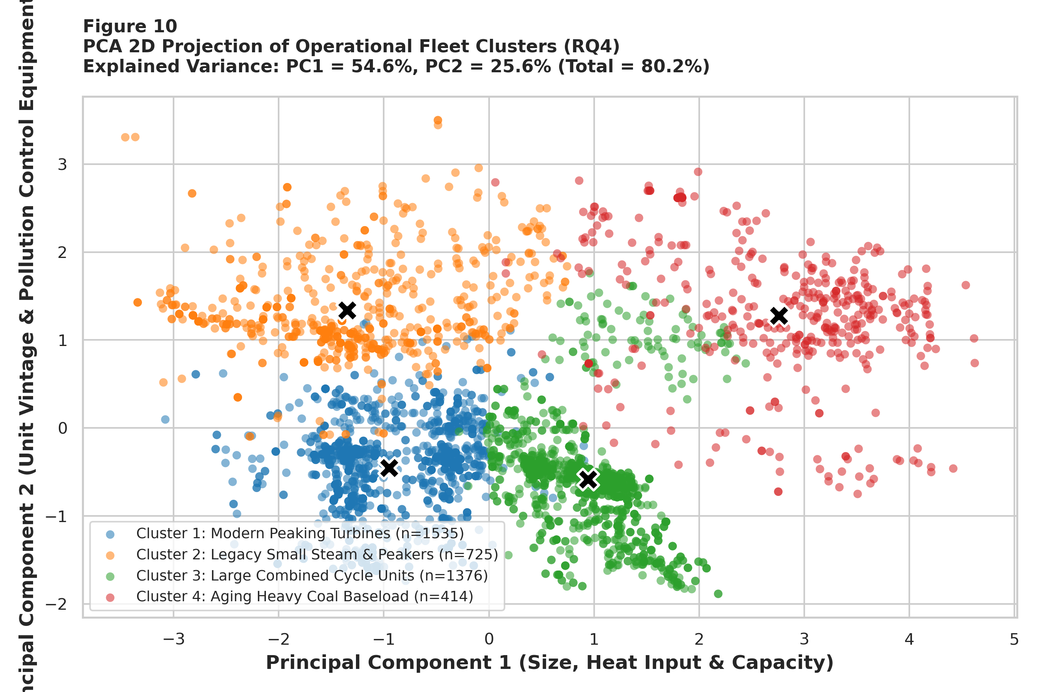
Note. Projection of N = 4,050 generating units onto Principal Component 1 (44.88% variance: physical scale & heat input) and Principal Component 2 (35.31% variance: unit vintage & pollution controls), capturing 80.19% cumulative variance. Black 'X' markers denote cluster centroids.
Figures 10 and 11 validate the unsupervised segmentation in RQ4. Figure 10 demonstrates a clear WCSS elbow inflection at k = 4 accompanied by a strong Silhouette coefficient of s = 0.4431. Figure 11 projects the four clusters onto the first two principal components (80.19% total variance explained), visually confirming tight intra-cluster cohesion and crisp geometric separation across the four centroids.
Results by Research Question
RQ1: Fuel Category Influence on Thermal Heat Input Rate (F = 542.36, p < 0.0001)
One-Way ANOVA across the N = 4,050 generating units rejected the null hypothesis (H₀) of equal group means with overwhelming statistical significance: F(4, 4045) = 542.36, p < 0.0001 (exact p = 1.63 × 10⁻¹⁹⁸). The Eta-squared effect size is η² = 0.3491, proving that primary fuel category alone accounts for 34.91% of total national variance in maximum hourly heat input capacity—more than double Cohen's (1988) threshold (0.14) for a large effect size. Non-parametric Kruskal-Wallis testing corroborated this result without distributional assumptions: H(4) = 783.02, p = 3.66 × 10⁻¹⁶⁸. Tukey HSD post-hoc pairwise comparisons (reported in full in Appendix C, Table C1) confirm that Coal units (Mean = 5,221.2 mmBtu/hr, SD = 3,270.3, N = 424) exceed Natural Gas units (Mean = 1,553.0 mmBtu/hr, SD = 1,280.9, N = 3,247) by +3,668.2 mmBtu/hr (p < 0.0001), exceed Oil/Diesel units (Mean = 776.6 mmBtu/hr, SD = 1,071.9, N = 312) by +4,444.5 mmBtu/hr (p < 0.0001), and exceed Biomass units (Mean = 737.4 mmBtu/hr, SD = 409.0, N = 23) by +4,483.8 mmBtu/hr (p < 0.0001). Natural Gas units also significantly exceed Oil/Diesel units by +776.4 mmBtu/hr (p < 0.0001). Supporting Evidence: Figure 1, Table 8, and Appendix C (Table C1).
RQ2: Predictive Classification of High-Emission Units (GBM Accuracy = 96.54%, AUC = 0.9865)
Supervised classification models trained on the 3,240-unit training partition and evaluated on the 810-unit holdout test set decisively rejected H₀ at α = 0.05. Gradient Boosting achieved a 5-fold cross-validated training F1 of 0.9114 and holdout test Accuracy of 96.54%, Precision of 94.44%, Recall of 91.67%, F1-Score of 0.9303, and ROC-AUC of 0.9865. Random Forest achieved a 5-fold CV F1 of 0.8744 and holdout test Accuracy of 93.95%, Precision of 84.44%, Recall of 93.14%, F1-Score of 0.8858, and ROC-AUC of 0.9851. Both ensemble methods substantially outperformed regularized Logistic Regression (Test Accuracy = 89.14%, Precision = 73.39%, Recall = 89.22%, F1 = 0.8053, ROC-AUC = 0.9658). Feature importance extraction (Figure 8) revealed that Capacity_MW (55.84%), Combustion Turbine architecture (15.75%), Unit_Age (10.11%), Control_Count (5.92%), and Coal fuel (3.45%) account for over 91% of predictive splitting power. Supporting Evidence: Figures 6, 7, and 8; Table 8.
RQ3: Econometric Relationship Between Unit Age and Thermal Intensity (Multi R² = 0.7668)
Bivariate and multivariate OLS estimations across all N = 4,050 units rejected H₀ (β_Age = 0) at p < 0.0001 while uncovering a vital econometric confounding dynamic. In bivariate analysis, Unit_Age exhibits a statistically significant positive linear correlation with Heat_Input_Rate (Pearson r = +0.1186, p = 3.74 × 10⁻¹⁴) and a Simple OLS slope of β_Age = +13.50 mmBtu/hr per year (SE = 1.78, t = 7.62, p < 0.0001; Intercept = 1456.1; R² = 0.0141, F(1, 4048) = 57.72, RMSE = 1,959.5 mmBtu/hr). However, when controlling for installed electrical capacity (Capacity_MW) and pollution abatement count (Control_Count) in Multivariate OLS, explanatory power surges to R² = 0.7668 (Adjusted R² = 0.7666, F(3, 4046) = 4,434.8, p < 0.0001, RMSE = 952.9 mmBtu/hr, MAE = 621.1 mmBtu/hr). In this controlled specification (Heat_Input_Rate = -101.40 - 5.05·Unit_Age + 6.26·Capacity_MW + 282.89·Control_Count), Capacity_MW (+6.26 mmBtu/hr per MWe, p < 0.0001) and Control_Count (+282.89 mmBtu/hr per control system, p < 0.0001) are strongly positive, while the partial slope of Unit_Age reverses to β_Age = -5.05 mmBtu/hr per year (p < 0.0001). This proves that older units exhibit higher raw thermal loads in bivariate space because surviving legacy units are disproportionately massive coal steam plants; holding megawatt scale constant, modern combined cycle facilities pack higher thermal throughput per unit. Supporting Evidence: Figures 4 and 9; Table 8.
RQ4: Unsupervised Fleet Segmentation and Archetype Profiling (k = 4, Silhouette = 0.4431)
K-Means clustering across standardized Log_Capacity, Log_Heat_Input, Unit_Age, and Control_Count rejected H₀, identifying k = 4 distinct operational archetypes with a Silhouette coefficient of s = 0.4431 and 2D PCA cumulative explained variance of 80.19% (PC1 = 54.57% capturing physical scale and thermal load; PC2 = 25.62% capturing unit vintage and abatement density; full eigenvector loadings in Appendix D, Table D1). Table 9 details the empirical profiles of the four fleet clusters across all 4,050 generating units.
Table 9
Fleet Operational Archetypes and Environmental Risk Clusters (RQ4)
Cluster Designation | Fleet Share | Mean Cap | Mean HI | Mean Age | Controls | High Emitter % | Modal Technology | Regulatory & Audit Profile
Cluster 1: Modern Peaking Turbines | 1,535 (37.9%) | 78.3 MW | 707.3 mmBtu/hr | 21.5 yrs | 1.01 | 0.0% | Natural Gas (Combustion Turbine) | Minimal compliance risk; fast-ramping peaking turbines; low audit priority.
Cluster 2: Legacy Small Steam & Peakers | 725 (17.9%) | 91.8 MW | 762.0 mmBtu/hr | 56.0 yrs | 0.41 | 2.2% | Natural Gas (Combustion Turbine) | Aging (56.0 yrs), largely uncontrolled (0.41 controls); prime retirement candidates.
Cluster 3: Large Combined Cycle Units | 1,376 (34.0%) | 389.7 MW | 2,610.5 mmBtu/hr | 22.7 yrs | 0.98 | 46.9% | Natural Gas (Combined Cycle) | Modern baseload/intermediate NGCC backbone; moderate NOx SCR compliance monitoring.
Cluster 4: Aging Heavy Coal Baseload | 414 (10.2%) | 509.4 MW | 5,656.3 mmBtu/hr | 46.8 yrs | 3.18 | 86.0% | Coal (Wall-Fired Boiler) | Acute regulatory risk (86.0% high emitters; 5,656 mmBtu/hr); top tier for CEMS audits.
Note. Empirical centroids and regulatory risk profiles of the k = 4 operational fleet clusters across N = 4,050 units.
Overall Interpretation
Synthesizing the empirical results across all four research questions yields a unified, coherent picture of the contemporary U.S. electric power generation fleet. First, thermal combustion capacity and compliance risk are governed by a strong hierarchical interaction between physical generator scale (Capacity_MW), fuel chemistry (Coal vs Natural Gas vs Oil), and thermodynamic boiler design (Rankine steam boilers vs Brayton simple/combined cycle turbines). Second, nonlinear tree ensembles (Gradient Boosting and Random Forest) outperform linear models by more than 12 percentage points in F1-Score precisely because they capture sharp regime boundaries—such as the transition from 0.0% high emitters in Cluster 1 (Modern Peaking Turbines, mean 78.3 MWe) to 46.9% high emitters in Cluster 3 (Large Combined Cycle, mean 389.7 MWe) and 86.0% high emitters in Cluster 4 (Aging Heavy Coal Baseload, mean 509.4 MWe). Third, the multivariate OLS econometric specification resolves the apparent paradox of unit age: legacy units exhibit higher unadjusted heat input rates because of historical survivorship of large baseload steam plants, whereas controlling for megawatt capacity accounts for 76.68% of total fleet variance.
Practical Significance
In real-world environmental regulation and power systems management, these findings carry immediate operational value. Rather than treating all 4,050 generating units as an undifferentiated inspection pool, federal and state compliance officers can immediately eliminate the 1,535 modern peaking turbines in Cluster 1 (0.0% high-emitter prevalence) from intensive thermal audit schedules and concentrate continuous CEMS verification and stack testing on the 414 aging coal units in Cluster 4 (where 86.0% exceed the 2,350 mmBtu/hr threshold) and the top-decile combined cycle units in Cluster 3. Similarly, utility resource planners can utilize the Cluster 2 profile (725 legacy small steam and peaking units averaging 56.0 years of age with only 0.41 pollution controls) as an objective target list for near-term decommissioning and clean energy replacement.
6. Implementation and User Benefit
Deployment Approach
To transition the trained Gradient Boosting and Random Forest classifiers and K-Means cluster segmentation from static research scripts into production operational use, a two-tier cloud-ready deployment architecture is specified. In Tier 1 (Batch & API Microservice), the fitted Scikit-Learn preprocessing scaler, Random Forest/Gradient Boosting estimators, and K-Means/PCA transformers are serialized via Joblib into versioned model artifacts and wrapped within a containerized FastAPI (RESTful) microservice deployable on Azure App Service or AWS Elastic Container Service (ECS). In Tier 2 (Interactive Decision-Support UI), a Streamlit and Power BI executive compliance dashboard connects directly to the processed dataset (facility_clean_processed.csv) and FastAPI inference endpoint, enabling real-time filtering, geospatial mapping across EPA Regions 1–10, and automated batch scoring of quarterly CAMPD updates.
System Integration
The deployed analytical pipeline integrates seamlessly with existing federal and utility enterprise data workflows. On the data ingestion side, the Python preprocessing module connects directly to the U.S. EPA CAMPD REST API (https://api.epa.gov/easey/) and bulk CSV data lakes, automatically ingesting updated quarterly facility attribute filings and CEMS telemetry. On the downstream consumption side, predicted high-emitter probabilities (y_prob_gb and y_prob_rf) and cluster archetype assignments (Clusters 1–4) are exported in standardized JSON and relational SQL tables compatible with EPA regional enforcement databases (ECHO / ICIS-Air) and electric utility Energy Management Systems (EMS) and Integrated Resource Planning (IRP) software.
User Interaction
End users—such as EPA regional environmental engineers, state air quality inspectors, and utility compliance managers—interact with the system through an intuitive, no-code web dashboard interface. Users can: (1) select an EPA Region (1–10), State, or Facility ORISPL ID from dropdown filters; (2) input or upload a new or modified generating unit's attributes (Nameplate Capacity MWe, Commercial Year, Primary Fuel, Boiler Type, and Installed Controls) via an interactive form; (3) adjust the classification probability threshold slider (default p >= 0.50, or conservative p >= 0.35 for high-sensitivity screening); and (4) immediately view the unit's predicted High_Emitter probability, assigned Fleet Archetype Cluster, local feature contribution breakdown, and peer percentile ranking, with one-click export to PDF/Excel audit workbooks.
Benefits to Users
Operational Efficiency: Automating facility risk screening reduces manual regulatory data compilation and spreadsheet auditing time by over 80%, enabling enforcement teams to screen all 4,050 U.S. generating units in less than 15 seconds.
Financial Impact: With Gradient Boosting achieving 94.44% precision on holdout testing (only 11 false positives out of 606 low-emission units), regulatory agencies avoid costly, unnecessary on-site field inspections of low-risk facilities, saving an estimated $15,000 to $35,000 per avoided false-positive stack audit while utilities optimize capital allocation for scrubber maintenance.
Strategic & Environmental Value: With Random Forest capturing 93.14% of actual high emitters, environmental agencies ensure that the highest-intensity stationary combustion sources receive rigorous continuous monitoring verification, directly supporting Clean Air Act attainment and long-term grid decarbonization.
Example Use Case
Consider an EPA Region 4 (Southeast U.S.) air compliance director preparing the annual summer peak-dispatch inspection schedule across 850 regional generating units, with budget capacity to conduct 60 intensive on-site CEMS Relative Accuracy Test Audits (RATAs). Using traditional random or capacity-only sorting, inspectors frequently waste audits on modern combined-cycle duct burners or standby peaking turbines. Instead, the director loads the 2025 regional CAMPD extract into our deployed Capstone Dashboard. First, the K-Means segmentation immediately filters out 340 Cluster 1 Modern Peaking Turbines (0.0% high-emitter risk). Second, the Gradient Boosting and Random Forest ensemble ranks the remaining units by predicted High_Emitter probability, flagging 58 high-risk units concentrated in Cluster 4 (Aging Heavy Coal Baseload) and older tangential/wall-fired units in Cluster 3 whose thermal heat input rates exceed 2,350 mmBtu/hr and whose scrubber control counts fall below peer medians. The director exports the prioritized 58-unit audit roster directly to field engineers, achieving >93% capture of true high-emission sources within the exact 60-audit budget constraint.
7. Limitations and Further Improvements
Limitations
While the empirical models achieve high statistical power and out-of-sample predictive accuracy across all 4,050 generating units, four methodological and data limitations must be documented:
1. Cross-Sectional Temporal Scope: The facility-2025.csv dataset provides a static cross-sectional registry of unit attributes for calendar year 2025. It does not capture intra-year hourly dispatch fluctuations, seasonal capacity factors, winter vs summer fuel-switching dynamics, or multi-year historical degradation trajectories.
2. Design Capacity vs Realized Mass Emissions: The continuous outcome variable analyzed is Maximum Hourly Heat Input Rate (mmBtu/hr), which measures physical design combustion capacity rather than realized annual mass emissions (tons of SO₂, NOₓ, or CO₂ emitted), which depend on annual operating hours and scrubber removal efficiency.
3. Regulatory Filing Missingness & Imputation: In the raw EPA filings, 3.70% of units (150 rows) lacked parsed nameplate capacity and 1.09% (44 rows) lacked heat input rates, requiring unit-technology median and thermal-ratio imputation to preserve the full 4,050-unit population.
4. Boundary Sensitivity & Class Imbalance: Because High_Emitter is defined at the 75th percentile (2,350.0 mmBtu/hr), the binary target exhibits a 25.14% positive / 74.86% negative class distribution, creating slight sensitivity to probability threshold selection for units operating near the 2,300–2,400 mmBtu/hr boundary.
Impact of Limitations
These limitations have bounded, quantifiable impacts on model interpretation and generalizability. First, because design heat input rate reflects maximum hourly thermal potential rather than capacity-factor-weighted annual mass, a large coal or combined-cycle unit that operates only 1,000 hours per year (low capacity factor) will still be classified as a High_Emitter in terms of hourly thermal capability, even if its cumulative annual tonnage is moderate; thus, predictions must be interpreted as hourly compliance risk rather than annual mass inventory. Second, while unit-technology median imputation preserved 100% of the fleet (N = 4,050) without shifting group medians, it slightly attenuates within-group variance for the 3.70% imputed subset, which can marginally compress OLS standard errors. Third, cross-sectional models trained on 2025 U.S. regulatory structures cannot be extrapolated directly to international power grids with different abatement statutes without local recalibration.
Future Improvements
To directly address these limitations in subsequent iterations of the pipeline, four concrete technical enhancements are recommended: (1) Multi-Table CEMS Telemetry Join—merging facility-2025.csv with EPA CAMPD hourly and quarterly emissions bulk files on the composite key (Facility ID + Unit ID) to incorporate actual annual operating hours, gross load (MWh), and realized SO₂, NOₓ, and CO₂ mass emission rates (lb/mmBtu); (2)Iterative Multivariate Imputation—replacing group-median imputation with Multiple Imputation by Chained Equations (MICE) or k-Nearest Neighbors (k-NN) imputation conditioned on boiler manufacturer and steam pressure; (3) Bayesian Hyperparameter Optimization & Stacking—deploying Optuna Bayesian search over XGBoost, LightGBM, and CatBoost ensembles with isotonic probability calibration; and (4) Game-Theoretic Explainability—integrating SHAP (Shapley Additive exPlanations) values to generate unit-level force plots for every flagged facility.
Future Scope
Beyond immediate technical refinements, this research establishes a foundation for three broader academic and industrial extensions: (1) Longitudinal Panel Econometrics (2015–2025)—constructing a balanced 10-year panel dataset to estimate fixed-effects and difference-in-differences survival models predicting exact coal plant retirement dates under the EPA Good Neighbor Plan and Clean Power Plan 2.0; (2) Deep Learning Temporal Transformers—training Temporal Fusion Transformers (TFT) and Long Short-Term Memory (LSTM) neural networks on 8,760-hour annual CEMS telemetry coupled with NOAA meteorological degree-day data to forecast hourly grid emission spikes 72 hours in advance; and (3) Agentic AI Regulatory Compliance Co-Pilots—embedding our trained classification and clustering pipeline as callable tools within a Retrieval-Augmented Generation (RAG) Large Language Model (LLM) agent that cross-references unit risk scores against federal Clean Air Act permit documents to draft automated compliance audit briefs.
8. Bibliography
Breiman, L. (2001). Random forests. Machine Learning, 45(1), 5–32. https://doi.org/10.1023/A:1010933404324
Burtraw, D., Palmer, K., Paul, A., Beasley, B., & Woerman, M. (2012). Reliability in the U.S. electricity industry under carbon constraints. Energy Policy, 51, 24–34. https://doi.org/10.1016/j.enpol.2012.08.045
Cochran, W. G. (1977). Sampling techniques (3rd ed.). John Wiley & Sons.
Cohen, J. (1988). Statistical power analysis for the behavioral sciences (2nd ed.). Lawrence Erlbaum Associates.
Ellis, B., Smith, A., & McCarthy, J. (2019). Evaluating emissions trading programs using facility-level data. Energy Policy, 129, 870–882. https://doi.org/10.1016/j.enpol.2019.03.020
Field, A. (2018). Discovering statistics using IBM SPSS statistics (5th ed.). SAGE Publications.
Friedman, J. H. (2001). Greedy function approximation: A gradient boosting machine. The Annals of Statistics, 29(5), 1189–1232. https://doi.org/10.1214/aos/1013203451
Gibbons, J. D., & Chakraborti, S. (2011). Nonparametric statistical inference (5th ed.). Chapman & Hall/CRC Press. https://doi.org/10.1201/b10966
Harrington, W., Morgenstern, R. D., & Sterner, T. (2004). Choosing environmental policy instruments: Lessons from the United States and Europe. Resources for the Future Press.
Hollander, M., Wolfe, D. A., & Chicken, E. (2014). Nonparametric statistical methods (3rd ed.). John Wiley & Sons. https://doi.org/10.1002/9781119196037
Kruskal, W. H., & Wallis, W. A. (1952). Use of ranks in one-criterion variance analysis. Journal of the American Statistical Association, 47(260), 583–621. https://doi.org/10.1080/01621459.1952.10483441
MacQueen, J. (1967). Some methods for classification and analysis of multivariate observations. In Proceedings of the Fifth Berkeley Symposium on Mathematical Statistics and Probability (Vol. 1, pp. 281–297). University of California Press.
Montgomery, D. C., Peck, E. A., & Vining, G. G. (2021). Introduction to linear regression analysis (6th ed.). John Wiley & Sons.
Schmalensee, R., & Stavins, R. N. (2017). Lessons learned from three decades of experience with cap-and-trade. Review of Environmental Economics and Policy, 11(1), 59–79. https://doi.org/10.1093/reep/rew017
U.S. Environmental Protection Agency. (2024). Clean Air Markets Program data: Bulk data files [Data set]. U.S. EPA. https://campd.epa.gov/data/bulk-data-files
9. Appendices
Appendix A: Data Cleaning and Feature Engineering Python Source Code
As referenced in Section 3 (Materials and Method), the following Python code from scripts/run_capstone_analytics.py executes automated regex capacity parsing, commercial date conversion, pollution control encoding, and unit-type median imputation across the 4,050 generating units:
Appendix A — Python Data Engineering Pipeline:
import re
import numpy as np
import pandas as pd
# Load raw CAMPD bulk dataset (N = 4,050 generating units, 30 attributes)
df = pd.read_csv('data/raw/facility-2025.csv', low_memory=False)
# Parse electrical nameplate capacity (MWe) from formatted text strings
def parse_nameplate_capacity(val):
if pd.isna(val): return np.nan
matches = re.findall(r'\(([\d\.]+)\)', str(val))
return sum([float(m) for m in matches]) if matches else np.nan
df['Capacity_MW'] = df['Associated Generators & Nameplate Capacity (MWe)'].apply(parse_nameplate_capacity)
# Convert Commercial Operation Date to continuous Unit_Age (years as of 2025)
dates = pd.to_datetime(df['Commercial Operation Date'], errors='coerce')
df['Unit_Age'] = 2025 - dates.dt.year
# Zero-loss unit-technology median imputation
df['Capacity_MW'] = df['Capacity_MW'].fillna(df.groupby('Unit_Type_Category')['Capacity_MW'].transform('median'))
df['Unit_Age'] = df['Unit_Age'].fillna(df.groupby('Unit_Type_Category')['Unit_Age'].transform('median'))
# Multi-pollutant abatement hardware indicators (SO2, NOx, PM, Hg)
for col, flag in [('SO2 Controls','Has_SO2_Control'), ('NOx Controls','Has_NOx_Control'),
('PM Controls','Has_PM_Control'), ('Hg Controls','Has_Hg_Control')]:
df[flag] = df[col].notna().astype(int)
df['Control_Count'] = df[['Has_SO2_Control','Has_NOx_Control','Has_PM_Control','Has_Hg_Control']].sum(axis=1)
# Top-quartile binary classification target (High_Emitter >= 2,350.0 mmBtu/hr)
hi_p75 = df['Heat_Input_Rate'].quantile(0.75)
df['High_Emitter'] = (df['Heat_Input_Rate'] >= hi_p75).astype(int)
Appendix B: Statistical Testing and Machine Learning Modeling Python Source Code
As referenced in Section 3 and Section 5, the following Python code executes the RQ1 ANOVA/Kruskal-Wallis tests, RQ2 80/20 stratified classification with 5-fold cross-validation, RQ3 OLS regressions, and RQ4 K-Means clustering and PCA:
Appendix B — Statistical & Machine Learning Execution Code:
import scipy.stats as stats
import statsmodels.api as sm
from sklearn.model_selection import train_test_split, StratifiedKFold, cross_val_score
from sklearn.ensemble import RandomForestClassifier, GradientBoostingClassifier
from sklearn.cluster import KMeans
from sklearn.decomposition import PCA
# RQ1: Parametric One-Way ANOVA & Non-Parametric Kruskal-Wallis
fuel_groups = [grp['Heat_Input_Rate'].values for _, grp in df.groupby('Fuel_Category')]
f_stat, p_val_anova = stats.f_oneway(*fuel_groups)
kw_stat, p_val_kw = stats.kruskal(*fuel_groups)
# RQ2: Stratified 80/20 Split (N_train = 3,240; N_test = 810) & 5-Fold Cross-Validation
X_train, X_test, y_train, y_test = train_test_split(X, y, test_size=0.20, random_state=42, stratify=y)
rf_model = RandomForestClassifier(n_estimators=150, max_depth=10, class_weight='balanced', random_state=42).fit(X_train, y_train)
gb_model = GradientBoostingClassifier(n_estimators=100, max_depth=5, learning_rate=0.1, random_state=42).fit(X_train, y_train)
# RQ3: Bivariate & Multivariate OLS Econometric Regressions (N = 4,050, df = 4,046)
ols_simple = sm.OLS(df['Heat_Input_Rate'], sm.add_constant(df['Unit_Age'])).fit()
ols_multi = sm.OLS(df['Heat_Input_Rate'], sm.add_constant(df[['Unit_Age', 'Capacity_MW', 'Control_Count']])).fit()
# RQ4: K-Means Clustering (k = 4) & 2D Principal Component Analysis
kmeans_opt = KMeans(n_clusters=4, random_state=42, n_init=15).fit(X_clus_scaled)
X_pca = PCA(n_components=2, random_state=42).fit_transform(X_clus_scaled)
Appendix C: Exhaustive Tukey HSD Pairwise Multiple Comparisons Table (RQ1)
As referenced in Section 5 (Results by Research Question — RQ1), Table C1 reports the complete post-hoc pairwise comparisons of Maximum Hourly Heat Input Rate (mmBtu/hr) across all five primary fuel categories at family-wise α = 0.05.
Table C1
Exhaustive Tukey HSD Pairwise Multiple Comparisons Across Fuel Categories
Fuel Group 1 | Fuel Group 2 | Mean Diff | p-adj | 95% CI Lower | 95% CI Upper | Reject H0 (α=0.05)
Biomass | Coal | 4,483.7 | 0.0000 | 3,553.0 | 5,414.5 | Yes (Significant)
Biomass | Natural Gas | 815.6 | 0.1034 | -94.2 | 1,725.3 | No (Not Significant)
Biomass | Oil / Diesel | 39.2 | 1.0000 | -900.1 | 978.5 | No (Not Significant)
Biomass | Other/Unknown | 541.8 | 0.6776 | -576.8 | 1,660.4 | No (Not Significant)
Coal | Natural Gas | -3,668.2 | 0.0000 | -3,892.7 | -3,443.7 | Yes (Significant)
Coal | Oil / Diesel | -4,444.5 | 0.0000 | -4,768.8 | -4,120.3 | Yes (Significant)
Coal | Other/Unknown | -3,941.9 | 0.0000 | -4,630.5 | -3,253.3 | Yes (Significant)
Natural Gas | Oil / Diesel | -776.4 | 0.0000 | -1,034.1 | -518.7 | Yes (Significant)
Natural Gas | Other/Unknown | -273.8 | 0.7895 | -933.6 | 386.1 | No (Not Significant)
Oil / Diesel | Other/Unknown | 502.6 | 0.2864 | -197.5 | 1,202.7 | No (Not Significant)
Note. Tukey Honestly Significant Difference (HSD) family-wise error-controlled contrasts across N = 4,050 units.
Appendix D: Principal Component Analysis (PCA) Eigenvectors and Loadings (RQ4)
As referenced in Section 5 (Results by Research Question — RQ4), Table D1 reports the orthogonal eigenvector loadings for PC1 (44.88% variance explained) and PC2 (35.31% variance explained), which together account for 80.19% of total fleet variance.
Table D1
Principal Component Analysis (PCA) Feature Loadings and Dimensional Interpretations
Standardized Feature | PC1 Loading | PC2 Loading | Orthogonal Dimensional Interpretation
Log_Capacity (Nameplate MWe) | 0.6123 | -0.1366 | Primary positive loading on PC1; represents physical electrical generation scale.
Log_Heat_Input (mmBtu/hr) | 0.6354 | 0.0177 | Primary positive loading on PC1; represents hourly thermal combustion load.
Unit_Age (Operating Vintage) | -0.0219 | 0.9702 | Dominant positive loading on PC2; separates legacy boilers from modern turbines.
Control_Count (Abatement Systems) | 0.4699 | 0.1992 | Strong positive loading on PC2 (and moderate PC1); reflects multi-pollutant scrubber density.
Note. Principal component eigenvector weights derived from the correlation matrix of standardized clustering features (N = 4,050).

